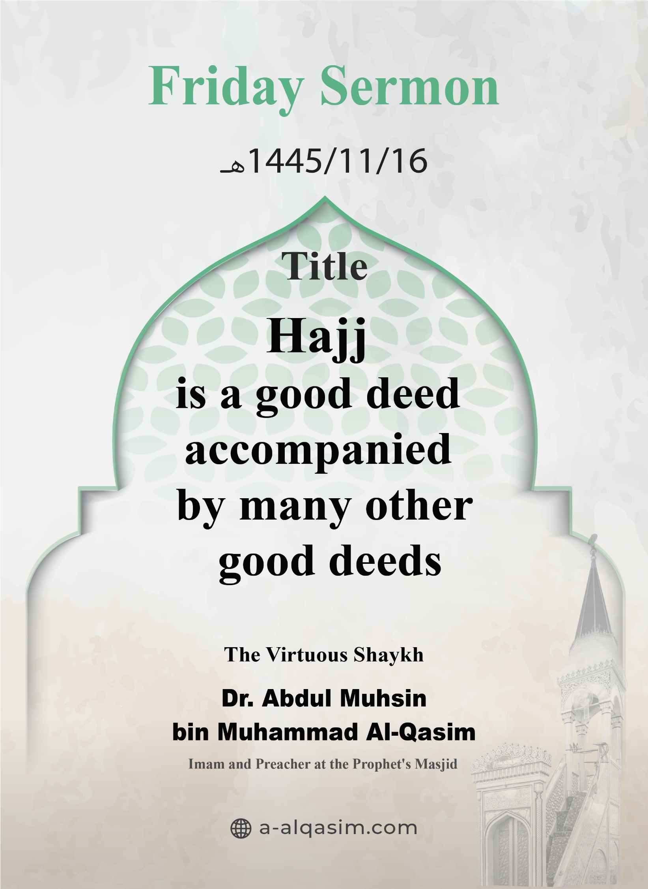

# Hajj is a good deed accompanied by many other good deeds([1])

Verily, all praise is for Allah. We praise Him, and seek His aid and forgiveness. We seek refuge in Allah from the evil of our souls, and from our bad deeds. Whomsoever Allah guides none can misguide, and whomsoever Allah leaves to go astray none can guide. I testify that there is none worthy of worship except Allah, alone with no partners. And I testify that our Prophet Muhammad is His slave and messenger. May Allah's peace and blessings be upon him, as well as his family and companions in abundance.

**Amma ba‘d:**[[2]]

O Slaves of Allah! Fear Allah as He deserves to be feared, and be conscious of Him in secret and in open.

**Ayyuhal-Muslimoon:**[[3]]

Allah (the Exalted) created the creation for His worship. He commanded them to obey Him, and prohibited them from disobeying Him. He obligated upon them various duties, which differ in their virtue, and some of which are more beloved to Him than others.

One of the greatest acts of obedience and the best means of drawing closer to Him is the Hajj (pilgrimage) to the Sacred House of Allah, which is one of the pillars and great fundamentals of Islam. The Prophet (may Allah's peace and blessings be upon him) was asked: "Which deeds are the best?" He replied: "**Belief in Allah and His Messenger.**" It was asked: "Then what?" He said: "**Jihad in the cause of Allah.**" It was asked: "Then what?" He said: "**A righteous Hajj.**" (Agreed upon).

Allah took an oath by the time in which it occurs, saying:

{ﱖ ﱗ}

{ By the ten nights } [Al-Fajr: 2]

And He swore by the place where it is performed, saying:

{ﱭ ﱮ ﱯ ﱰ}

{I swear by this city. (Makkah)} [Surah Al-Balad: 1]

He, glorified be He, chose the best and most beloved of lands to Him, for the rites of Hajj to be performed there. No place on earth is circumambulated around except the revered Ka'bah.

It is an obligation and a form of worship. The Prophet (may Allah's peace and blessings be upon him) said: "**O people, Allah has made Hajj obligatory for you, so perform Hajj.**" (Narrated by Muslim).

Its virtues are continuous for the pilgrim from the moment he begins his rituals. When he makes the Talbiyah, everything moist and dry in the entire land responds in unison. The Prophet (may Allah's peace and blessings be upon him) said: "**There is no Muslim who recites the Talbiyah, except that the rocks, trees, and clods to his right and left recite it with him, to the furthest point to the east and the west**" – meaning from his right and his left. (Narrated by Ibn Majah).

The pilgrims are the delegation of Allah who come to seek His favour. The Prophet (may Allah's peace and blessings be upon him) said: "**The delegation of Allah is three [types of people]: the warrior, the one performing Hajj, and the one performing Umrah.**" (Narrated by An-Nasai).

Hajj erases sins and mistakes. The Prophet (may Allah's peace and blessings be upon him) said: "**Hajj wipes out whatever came before it**" (Narrated by Muslim). It purifies the pilgrim from sins, if they refrain from all disobedience, as well as sexual intercourse, and alluding to it. The Prophet (may Allah's peace and blessings be upon him) said: "**Whoever performs Hajj for the sake of Allah and does not have sexual intercorse or perform an act of transgression, will return free from sins as the day his mother gave birth to him**" (Agreed upon). Shaykh   
Al-Islam said: "Erasing sins can sometimes be for minor sins and sometimes for major sins, depending on how the good and evil deeds balance out. Sometimes, a person may perform a single action with complete sincerity and devotion to Allah, so Allah forgives his major sins because of it."

Allah boasts to His angels about the pilgrims, as the Prophet (may Allah's peace and blessings be upon him) said: "**There is no day on which Allah frees more people from the Fire than the Day of Arafah. He comes close and expresses His pride to the angels, saying: 'What do these people want?'**" (Narrated by Muslim). Ibn 'Abd al-Barr (may Allah have mercy on him) said: "This indicates that they are forgiven, because Allah does not boast about the people of sins and transgressions except after repentance and forgiveness."

And whoever performs Hajj with all its pillars, obligations, a sincere intention, and not polluting it with any sins, then his reward is Paradise. The Prophet (may Allah's peace and blessings be upon him) said: "**The accepted Hajj has no reward but Paradise.**" (Agreed upon).

Hajj is an act of obedience accompanied by other acts of obedience. It is filled with benefits, lessons, and signs. Allah (may He be glorified) said:

{ﲆ ﲇ ﲈ}

{That they may witness benefits for themselves} [Al-Hajj: 28]

Al-Qurtubi (may Allah have mercy on him) said: "Benefits for them include worship, trade, forgiveness, worldly benefits, and benefits in the Hereafter."

The greatest way for worshippers to draw closer to Allah during their Hajj is to demonstrate their Tawheed of Allah in their rituals, to devote their acts of worship sincerely to Him, and to submit themselves to Him in servitude and humility. Allah (may He be glorified) said:

{ﲠ ﲡ ﲢ ﲣﲤ}

{And properly complete the Hajj and Umrah for Allah.} [Al-Baqarah: 196]

Declaring the Tawheed of Allah in Hajj is the distinguishing mark of the pilgrims and a means of honour for them. "**Labbayk Allahumma Labbayk, Labbayk Laa Shareeka Laka Labbayk, Innal Hamda Wan Ni'mata Laka Wal Mulk, Laa Shareeka Lak (Here I am, O Allah, here I am. Here I am, You have no partner, here I am. Verily all praise and blessings are Yours, and all sovereignty, You have no partner).**" (Agreed upon). Sheikh Al-Islam (may Allah have mercy on him) said: "Hajj is based on humility and submission to Allah, which is why it is specifically called 'nusuk'."

Hajj is an important means to achieve following and emulating the Prophet (may Allah's peace and blessings be upon him); for there is no correct rituals or acts of worship except that which in accordance with his guidance. He (may Allah's peace and blessings be upon him) said: "**Take your rituals from me, for I do not know if I will perform Hajj again.**" (Narrated by Muslim). Following the Prophet (may Allah's peace and blessings be upon him) is evidence of a person's truthfulness, faith, and love. Allah (the Exalted) said:

{ﱞ ﱟ ﱠ ﱡ ﱢ ﱣ ﱤ ﱥ ﱦ ﱧ ﱨﱩ ﱪ ﱫ ﱬ}

{Say, [O Prophet,] “If you [sincerely] love Allah, then follow me; Allah will love you and forgive your sins. For Allah is All-Forgiving, Most Merciful. } [Aal 'Imran: 31]

And every act of worship contrary to his guidance (may Allah's peace and blessings be upon him) is not accepted by Allah. The Prophet (may Allah's peace and blessings be upon him) said: "**Whoever does an act that is not in accordance with our matter, it is rejected.**" (Narrated by Muslim).

A Muslim adheres to his religion and distances himself from the actions and conduct of Jahiliyyah (the times of Pre-Islamic Ignorance). In Hajj, there is constantly emphasised over and over again. Ibn al-Qayyim (may Allah have mercy on him) said: "The legislation is based on opposing the polytheists, especially in the rituals [of Hajj and Umrah]."

In Hajj, there is humility towards Allah and His creation, and an acknowledgment that pride belongs solely to Allah (may He be glorified) alone. This is declared through Takbir during the Ramy (stoning of the pillars), Tawaf (circumambulation), and on Yawm An-Nahr (the Day of Sacrifice), and during the days of Tashriq, so that the hearts remain attached to Allah, pure from everything else.

The remembrance of Allah accompanies the pilgrims whenever they stop or set out, when they ascend or descend, and it continues to accompany them even after they have completed their rituals. Allah (the Exalted) said:

{ﲎ ﲏ ﲐ ﲑ ﲒ ﲓ ﲔ ﲕ ﲖ ﲗﲘ}

{So when you have completed your rites, remember Allah like your [previous] remembrance of your fathers or with [much] greater remembrance.} [Al-Baqarah: 200]

Ibn al-Qayyim (may Allah have mercy on him) said: "The best of people in every action are those who remember Allah the most during it... and the best of those performing Hajj are those who remember Him the most."

In the state of Ihram, there is a call to the soul to disobey its desires, so there is no fitted clothing, no applying of perfume, no trimming of nails, and no marriage proposal during it. The differences of worldly adornments disappear, and people appear equal without distinction in appearance; everyone's attire is like that of the shrouds [which the deceased are clothed in].

In Hajj, the greatness of Islam is manifested in unifying various groups of people on the truth, gathering them on the word of Islam, heading towards one place, calling upon one Lord, following one Prophet, and reciting one book.

The boundaries of races, languages, countries and colours all fade away, and the scales of piety and faith become apparent:

{ﱥ ﱦ ﱧ ﱨ ﱩ ﱪ ﱫ ﱬ ﱭ ﱮ ﱯﱰ ﱱ ﱲ ﱳ ﱴ ﱵﱶ }

{O mankind, indeed We have created you from male and female and made you peoples and tribes that you may know one another. Indeed, the most noble of you in the sight of Allah is the most righteous of you.} [Al-Hujurat: 13]

The Muslims unite and the bonds of love strengthen among them, showing the creation the greatness of Islam and its virtue, as well as the honour and high status of this nation. Allah (may He be glorified) said:

{ﱏ ﱐ ﱑﱒ ﱓ ﱔ ﱕ ﱖ ﱗ ﱘ ﱙ ﱚ ﱛ ﱜ  
 ﱝ ﱞ ﱟ ﱠﱡ}

{And He has united their hearts. If you had spent all that is in the earth, you could not have united their hearts, but Allah has united them.} [Al-Anfal: 63]

The adornment of the pilgrims is the display of their beautiful character. Allah (the Exalted) says:

{ﱅ ﱆ ﱇ ﱈ ﱉ ﱊ ﱋ ﱌ}

{So whoever has made Hajj obligatory upon himself therein [by entering the state of ihram], there is [to be for him] no sexual relations and no disobedience.} [Al-Baqarah: 197]

And among the righteousness that takes place during Hajj is feeding others, spreading the Salam (greeting of peace), speaking kindly, and treating people with excellence.

The kindness towards pilgrims is a worship that has multiple benefits. Mujahid (may Allah have mercy on him) said: "I accompanied Ibn 'Umar (may Allah be pleased with him) on a journey to serve him, and he used to serve me." Ibn Rajab (may Allah have mercy on him) said: "Many of the early Muslims used to stipulate that they serve their companions during the journey, taking it as an opportunity to earn reward."

The pilgrim reflects on the humiliation of Iblees at the site of stoning the pillars, when he appeared to Ibrahim (peace be upon him) three times to prevent him from obeying his Lord's command to sacrifice his son Isma'il. Ibrahim Al-Khalil [– the beloved friend of Allah –] threw stones at him, humiliating him and showing enmity towards him. Him returning to Ibrahim serves as a reminder to us that Iblees continues to whisper to the children of Adam, and does so in various situations.

The black stone serves as a reminder to worshippers of the severity of sin, even on inanimate objects, and its impact on the heart is even greater. The Prophet (may Allah's peace and blessings be upon him) said: "**The Black Stone descended from Paradise and it was whiter than milk, but the sins of the children of Adam turned it black.**" (Narrated by At-Tirmidhi).

In Hajj, there is a discipline for the soul and training it to abandon desires; the pilgrim leaves some permissible things like normal [fitted] clothes and perfume. Whoever restrains himself from the prohibitions of Ihram during his pilgrimage, it is befitting for him to restrain himself from sins at all times and places.

It encourages perfecting one's actions and emphasizes the importance of time. As the sun sets, there is movement from one spot to another, and a transition from one ritual to another, with no action preceding another. It is a complete system in life and the rites of worship, and sincerity and obedience stem from it.

Whoever announces the Talbiyah in his Hajj with monotheism, and proclaims the greatness of Allah on the day of Eid, must fulfil their promise to Allah by not invoking anyone else, not seeking help from others, and not circumambulating anything other than the Kaaba. Allah (may He be glorified) said:

{ﱷ ﱸ ﱹ ﱺ ﱻ ﱼ ﱽ ﱾ}

{And those you call upon besides Him do not possess [as much as] the thin skin over a date seed } [Fatir: 13]

And whoever turns to Allah, He will assist them. Allah says:

{ﲐ ﲑ ﲒ ﲓ ﲔﲕ ﲖ ﲗ ﲘ ﲙ}

{And those who strive in Our cause, We will surely guide them to Our ways.} [Al-'Ankabut: 69]

Every Muslim yearns to see the Kaaba and perform Tawaf around it. People come to it from all directions and regions. It is the greatest gathering place of Islam, where crowds come together in response to the call of their father Ibrahim. The hearts of Muslims continue to yearn for the Sacred House, hoping to see it, perform Tawaf around it, and stay close to it engaging in worship.

**Wa Ba‘d**[[4]]**, Ayyuhal-Muslimoon:**

The moments of Hajj are precious and its hours are valuable. Allah (the Exalted) said:

{ﱂ ﱃ ﱄ ﱅ ﱆﱇ}

{And remember Allah during the appointed days.} [Al-Baqarah: 203]

This is a reminder to prepare for the journey to the Hereafter. The pilgrim leaves behind his wealth and family to embark on the Hajj. It is the last pillar of Islam, performed in the last month of the [Hijri] year. The Prophet (may Allah's peace and blessings be upon him) performed it towards the end of his life. Wearing the Ihram is a reminder of the shroud [worn by the deceased], and the gathering of worshippers and standing at the sacred sites is a reminder of their gathering in the Hereafter and standing before Allah.

**A‘udhu billahi minash-shaytanir-rajim**[[5]]

{ﱷ ﱸ ﱹ ﱺ ﱻ ﱼ ﱽ ﱾ ﱿ ﲀ ﲁ ﲂ ﲃ ﲄ}

{And proclaim to the people the Hajj [pilgrimage]; they will come to you on foot and on every lean camel; they will come from every distant pass.} [Al-Hajj: 27]

May Allah bless me and you…

# The Second Sermon

All praise is to Allah for His excellence and kindness, and gratitude is due to Him for His guidance and favours. I testify that there is none worthy of worship except Allah alone having no partners, glorifying Him; and I testify that Muhammad is His slave and messenger, may Allah's peace and blessings be upon him, as well as his family and companions in abundance.

**Ayyuhal-Muslimoon:**

The one who does not perform a righteous action due to a valid excuse accompanies those who perform it [in its reward] if his intention is true and sincere. Perhaps the one migrating with his heart [towards Allah's pleasure] has preceded those travelling with their bodies. Whoever misses standing at Arafah, let him fulfil the rights of Allah that He has taught him. And whoever is unable to spend the night at Muzdalifah, let him strengthen his resolve to obey Allah. Fasting on the day of Arafah is legislated for him. The Prophet (may Allah's peace and blessings be upon him) said: "**I hope in Allah that fasting on the day of Arafah will expiate the sins of the previous year and the year to come.**" (Narrated by Muslim).

So, participate with the pilgrims in these ten days with supplication, Tahlil (saying: La Ilaha Illa Allah), Takbir (saying: Allahu Akbar), Tahmid (saying: Alhamdulillah), and all types of Allah's remembrance, and engage in them abundantly at all times. For "**there are no days in which righteous deeds are more beloved to Allah than in these ten days**". (Narrated by At-Tirmidhi). Make the most of the seasons of worship before they pass, for life is a profit, but the days are numbered, and lifespans are short.

Thereafter, know that Allah has commanded you to…

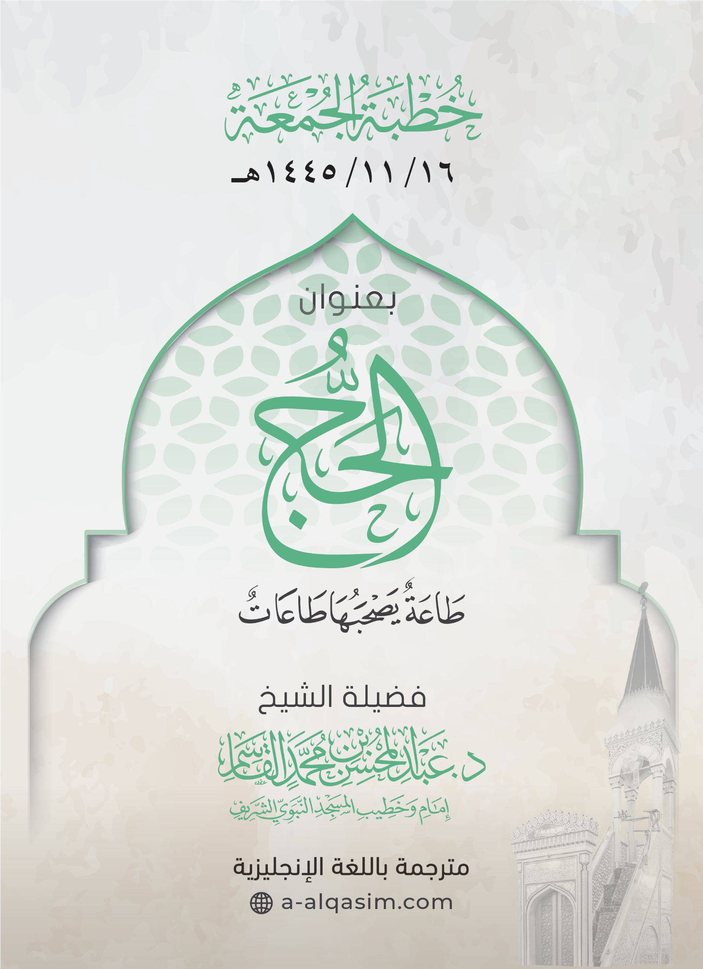

1. () This khutbah was delivered in Al-Masjid An-Nabawi on Friday the 16th of   
   Dhul-Qa'dah 1445AH.
2. [] Translator's note: "Amma ba‘d" is a phrase used to separate between the introduction and the topic of the sermon. It can be translated as: "To proceed".
3. [] Translator's note: "Ayyuhal-Muslimoon" is an address meaning: "O Muslims".
4. [] Translator's note: When coming at the end of a sermon, this phrase can be understood to mean: "To conclude".
5. [] Translator's note: This phrase means: "I seek refuge in Allah from the accursed Shaytan".