خطبة الأسبوع

معركةُ الدُّيـون!

The Battle of Debt!

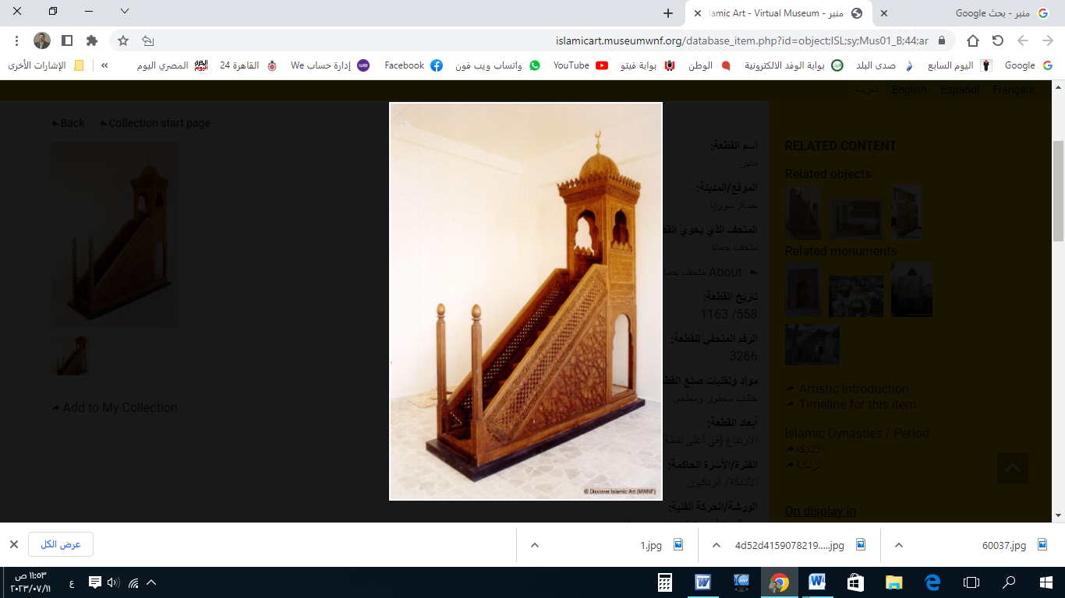

**قناة الخُطَب الوَجِيْزَة**

https://t.me/alkhutab

الخُطْبَةُ الأُوْلَى

إِنَّ الحَمْدَ للهِ، نَحْمَدُهُ وَنَسْتَعِينُهُ، وَنَسْتَغْفِرُهُ ونَتُوبُ إِلَيه، مَنْ يَهْدِ اللهُ فَلَا مُضِلَّ لَهُ، وَمَنْ يُضْلِلْ فَلَا هَادِيَ لَهُ، وَأَشْهَدُ أَنْ لَا إِلَهَ إِلَّا اللهُ وَحْدَهُ لَا شَرِيكَ لَهُ، وَأَشْهَدُ أَنَّ مُحَمَّدًا عَبْدُهُ وَرَسُولُهُ**.**

أَمَّا بَعْد: فَأُوْصِيْكُمْ ونَفْسِي بِتَقْوَى اللهِ : بِفِعْلِ طَاعَتِهِ، والخَوفِ مِنْ مَعصِيَتِه؛ فَمَنْ خَافَ مِنَ اللهِ، أمَّنَهُ يَوْمَ يَلْقَاه! قال تعالى: ﴿**إِنَّ المُتَّقِينَ في جَنَّاتٍ وَعُيُونٍ**\* **ادْخُلُوهَا بِسَلَامٍ آمِنِينَ**﴾.

To proceed: I advise you and myself to have *taqwa* (consciousness) of Allah: by obeying Him and fearing disobedience to Him. Whoever fears Allah, He will grant them safety on the Day they meet Him. Allah says: *"****Indeed, the righteous will be among gardens and springs. Enter it in peace, safe and secure****."*

عِبَادَ الله: قَدْ يَدْخُلُ الإِنْسَانُ في مَعْرَكَةٍ لا يُرِيْدُهَا، ولَكِنَّ ظُرُوْفَ الحياةِ المَادِيَّةِ، ومَطَالِبَها اليَوْمِيَّة؛ قَدْ تَدْفَعُهُ دَفْعًا إلى مَعْرَكَةٍ طَوِيْلَةِ الأَجَل؛ إِنَّهَا **مَعْرَكَةُ الدُّيُون**!

Servants of Allah, a person may enter into a battle they do not want, but life’s material demands and daily needs may push them into a long struggle. This is **the battle of debt!**

والدَّيْنُ أَوَّلُهُ لَذَّةٌ، وآخِرُهُ مَذَلَّة! والأَصْلُ أَلَّا يُشْغِلَ الإنسانُ ذِمَّتَهُ في دَيْنٍ لا حَاجَةَ لَهُ فِيه، فَإِنَّ **حُقُوقَ النَّاسِ مَبْنِيّةٌ على المُشَاحَّة**! وَتَرَى كَثِيرًا مِن النَّاسِ يَتَسَاهَلُونَ في الدَّيْنِ، ويَحْسَبُونَهُ هَيِّنًا وَهُوَ عِنْدَ اللهِ عَظِيم! قال ﷺ: **(يُغْفَرُ لِلشَّهِيدِ كُلُّ ذَنْبٍ إِلَّا الدَّيْنَ**!).

Debt begins with pleasure but ends in humiliation. It is essential that a person does not burden themselves with debt unnecessarily, as people’s rights are strict. Yet, many people take on debt lightly, thinking it is insignificant, while it is a serious matter in the sight of Allah. The Prophet ﷺ said: *"****Every sin of the martyr will be forgiven except for debt****."*

وَمِنْ أَعْظَمِ الأَسْلِحَةِ في مَوَاجَهَةِ الدُّيُون: **النِيَّةُ** الحَسَنَةُ، والحِرْصُ على الوَفَاءِ؛ قال ﷺ: (**مَنْ أَخَذَ أَمْوَالَ النَّاسِ يُرِيدُ أَدَاءَهَا: أَدَّى اللهُ عَنْهُ، وَمَنْ أَخَذَ يُرِيدُ إِتْلاَفَهَا: أَتْلَفَهُ اللهُ**). قال ابنُ حَجَر: (**قَوْلُهُ: "أَتْلَفَهُ اللهُ": ظَاهِرُهُ أَنَّ الإِتْلَافَ يَقَعُ لَهُ في الدُّنْيَا: وذَلِكَ في مَعَاشِهِ، أو في نَفْسِهِ؛ وهُوَ عَلَمٌ مِنْ أَعْلَامِ النُبُوَّةِ؛ لِمَا نَرَاهُ بِالمُشَاهَدَةِ!**).

One of the greatest weapons in dealing with debt is good intention and being diligent in repayment. The Prophet ﷺ said: *"****Whoever takes the money of people intending to repay it, Allah will repay on his behalf; and whoever takes it intending to waste it, Allah will ruin him****."* Ibn Hajar said: *"****His saying ‘Allah will ruin him’ apparently means that destruction will occur to him in this world, either in his livelihood or in his own self; and this is one of the signs of Prophethood, as we see this happening in reality****."*

وَمِنْ أَعْظَمِ أَسْلِحَةِ المُؤْمِنِ الَّتِي يَسْتَعِينُ بِهَا على قَضَاءِ دَيْنِهِ: أَنْ يَقْرَعَ بَابَ السَّمَاء، وأَنْ يَلْتَجِئَ إلى اللهِ بِالدُّعَاء؛ قال عليُّ بنُ أَبِي طَالِبٍ : (**أَلَا أُعَلِّمُكَ كَلِمَاتٍ عَلَّمَنِيْهِنَّ رَسُولُ اللهِ ﷺ، لَوْ كَانَ عَلَيْكَ مِثْلُ جَبَلِ صِيْرٍ[1] دَيْنًا؛ أَدَّاهُ اللهُ عَنْكَ! قُلِ: "اللَّهُمَّ اكْفِنِي بِحَلَالِكَ عَنْ حَرَامِكَ، وَأَغْنِنِي بِفَضْلِكَ عَمَّنْ سِوَاكَ"**).

Another great weapon a believer uses to repay debt is turning to the heavens, seeking refuge in Allah through *du’a* (supplication). Ali ibn Abi Talib (may Allah be pleased with him) said: *"****Shall I teach you some words that the Messenger of Allah ﷺ taught me? Even if you had a debt as large as Mount Seer, Allah would repay it for you. Say****: ‘****O Allah, suffice me with what You have made lawful instead of what You have made unlawful, and enrich me by Your bounty instead of from anyone else****.’"*

وَمِمَّا يُعِيْنُ على قَضَاءِ الدَّيْن: **ترَتِيْبُ الأَوْلَوِيَّات**: فَالنَّفَقَاتُ **الوَاجِبَةُ:** أَوْلَى مِنَ المُسْتَحَبَّةِ، و**الضَّرُوْرِيَّاتُ:** أَوْلَى مِنَ الكَمَالِيَّات؛ فَيَنْبَغِي لِلْمَدِيْنِ: أَنْ يُقَدِّمَ سَدَادَ الدُّيُونِ على الكَمَالِيَّات، بل وعلى نَوَافِلِ الصَّدَقَات؛ فَإِنَّ الدَّائِنِيْنَ أَوْلَى بِمَا زَادَ عَنِ النَّفَقَاتِ الضَّرُوْرِيَّةِ والحَاجِيَّة.

Another method that helps in repaying debt is prioritizing expenses: Obligatory expenses are more important than recommended ones, and necessities are more important than luxuries. Therefore, the person in debt should prioritize repaying debts over luxuries and even over voluntary charity, as creditors have more right over anything extra beyond necessary and essential expenses.

ومَنْ مَاتَ وعَلَيْهِ دَيْنٌ، فَيَجِبُ سَدَادُ دَيْنِهِ قَبْلَ قِسْمَةِ التَّرِكَة، وقَبْلَ الوَصِيَّةِ. قال ﷺ: (**نَفْسُ المُؤْمِنِ مُعَلَّقَةٌ بِدَيْنِهِ حَتَّى يُقْضَى عَنْهُ**).

If someone dies while still in debt, their debt must be settled before the inheritance is distributed and before fulfilling any wills. The Prophet ﷺ said: *"****A believer's soul is held back by their debt until it is paid off.****"*

وإِذَا أَصْلَحَ (المَدِيْنُ) مَا بَيْنَهُ وبَيْنَ اللهِ : **أَصْلَحَ لَهُ** مَا بَيْنَهُ وبَيْنَ الدَّائِنِيْنَ؛ فَقَدْ وَعَدَ اللهُ أَهْلَ التَّقْوَى والاِسْتِغْفَارِ: بِالفَرَجِ والاِنْتِصَارِ؛ فقال تعالى: ﴿**وَمَنْ يَتَّقِ اللهِ يَجْعَلْ لَهُ مَخْرَجًا* وَيَرْزُقْهُ مِنْ حَيْثُ لا يَحْتَسِبُ**﴾، وقال : ﴿**فَقُلْتُ اسْتَغْفِرُوا رَبَّكُمْ إِنَّهُ كَانَ غَفَّاراً يُرْسِلِ السَّمَاءَ عَلَيْكُمْ مِدْرَاراً وَيُمْدِدْكُمْ بِأَمْوَالٍ وَبَنِينَ**﴾.

If the debtor fixes their relationship with Allah, Allah will improve their situation with their creditors. Allah has promised those who have *taqwa* and seek forgiveness relief and victory. Allah says: *"****And whoever fears Allah – He will make for him a way out, and will provide for him from where he does not expect****."* And Allah says: *"****So I said, 'Seek forgiveness from your Lord. Indeed, He is ever a Perpetual Forgiver. He will send [rain from] the sky upon you in continuing showers and give you increase in wealth and children****."*

والوَاجِبُ على مَنْ عَلَيْهِ دَيْنٌ: أَنْ يُوَثِّقَهُ في وَصِيَّتِه؛ خَشْيَةَ أنْ يُفَاجِئَهُ الموتُ قَبْلَ سَدَادِه؛ قال ﷺ: (**مَا حَقُّ امْرِئٍ مُسْلِمٍ، لَهُ شَيْءٌ يُوصِي فِيهِ، يَبِيتُ ثَلَاثَ لَيَالٍ؛ إِلَّا وَوَصِيَّتُهُ عِنْدَهُ مَكْتُوبَةٌ**).

It is obligatory for anyone who is in debt to document it in their will, fearing that death may come unexpectedly before the debt is repaid. The Prophet ﷺ said: *"****It is not right for a Muslim who has something to will to stay for two nights without having his will written and kept ready with him****."*

أَقُوْلُ قَوْلِي هَذَا، وَأسْتَغْفِرُ اللهَ لِيْ وَلَكُمْ مِنْ كُلِّ ذَنْبٍ؛ فَاسْتَغْفِرُوْهُ إِنَّهُ هُوَ الغَفُورُ الرَّحِيم

الخُطْبَةُ الثَّانِيَة

الحَمْدُ للهِ عَلَى إِحْسَانِه، والشُّكْرُ لَهُ عَلَى تَوْفِيْقِهِ وَامْتِنَانِه، وَأَشْهَدُ أَنْ لا إِلَهَ إِلَّا الله، وَأَنَّ مُحَمَّدًا عَبدُهُ وَرَسُولُه.

عِبَادَ الله: الوَاجِبُ على (صَاحِبِ الدَّيْنِ) إِذَا حَلَّ دَيْنُهُ: إِنْظَارُ (المَدِيْنِ) إِذَا كانَ (**مُعْسِرًا عَاجِزًا**)؛ لِقَوْلِهِ تَعَالَى: ﴿**وَإِن كَانَ ذُو عُسْرَةٍ فَنَظِرَةٌ إِلَى مَيْسَرَة**﴾، أَمَّا إِذَا **أَبْرَأَهُ مِنَ الدَّيْنِ**: فَذَلِكَ خَيرٌ وأَفْضَلُ؛ قال ﷺ: (**مَنْ أَنْظَرَ مُعْسِرًا، أَوْ وَضَعَ عَنْهُ؛ أَظَلَّهُ اللهُ في ظِلِّهِ**).

Servants of Allah, it is obligatory for the creditor, when their debt is due, to give the debtor a grace period if they are struggling and **unable to pay**. This is based on Allah’s statement: *"****And if someone is in hardship, then [let there be] postponement until [a time of] ease****."* However, if the creditor forgives the debt, that is even better and more virtuous. The Prophet ﷺ said: *"****Whoever gives a debtor respite or forgives him, Allah will shade him in His shade****."*

وإِذَا كَانَ المَدِيْنُ: (**مُوْسِرًا قَادِرًا**): فَيَحِقُّ لِلْدَّائِنِ إِجْبَارُهُ على الأَدَاءِ، ويَحْرُمُ على المَدِيْنِ أنْ يُمَاطِلَ؛ قال ﷺ: (**مَطْلُ الغَنِيِّ ظُلْمٌ**).

If the debtor is **able to pay**, it is the creditor’s right to demand repayment, and it is forbidden for the debtor to delay without a valid reason. The Prophet ﷺ said: *"****Delaying payment by a wealthy person is injustice.****"*

والمُنْتَصِرُ في مَعْرَكَةِ الدُّيُون، هُوَ مَنْ خَرَجَ مِنَ الدُّنيا، وقَدْ قَضَى دُيُونَ النَّاس، وأَدَّى حُقُوْقَهُم ﴿**مِنْ قَبْلِ أَنْ يَأْتِيَ يَوْمٌ لَا بَيْعٌ فِيهِ وَلَا خُلَّةٌ وَلَا شَفَاعَةٌ**﴾. وقال ﷺ: (**مَنْ كَانَتْ عِنْدَهُ مَظْلِمَةٌ لِأَخِيهِ؛ فَلْيَتَحَلَّلْهُ مِنْهَا، فَإِنَّهُ لَيْسَ ثَمَّ دِينَارٌ وَلاَ دِرْهَمٌ، مِنْ قَبْلِ أَنْ يُؤْخَذَ لِأَخِيهِ مِنْ حَسَنَاتِهِ، فَإِنْ لَمْ يَكُنْ لَهُ حَسَنَاتٌ: أُخِذَ مِنْ سَيِّئَاتِ أَخِيهِ، فَطُرِحَتْ عَلَيْهِ**!).

The one who is truly successful in the battle against debt is the one who leaves this world having settled their debts and fulfilled the rights of others ***"before a Day comes in which there will be no bargaining, no friendship, and no intercession****."* The Prophet ﷺ also said: *"****Whoever has wronged his brother, let him seek forgiveness from him before a day comes when there will be no dinar or dirham. On that Day, if he has good deeds, they will be taken from him to repay his brother, and if he has no good deeds, his brother's sins will be placed on him.****"*

******

**\* اللَّهُمَّ** أَعِزَّ الإِسْلامَ والمُسْلِمِينَ، وأَذِلَّ الشِّرْكَ والمُشْرِكِيْن.

* **اللَّهُمَّ** ارْضَ عَنْ خُلَفَائِكَ الرَّاشِدِيْن، الأَئِمَّةِ المَهْدِيِّين: أبي بَكْرٍ، وعُمَرَ، وعثمانَ، وعَلِيّ؛ وعَنْ بَقِيَّةِ الصَّحَابَةِ والتابعِين، ومَنْ تَبِعَهُمْ بِإِحْسَانٍ إلى يومِ الدِّين.

* **اللَّهُمَّ** فَرِّجْ هَمَّ المَهْمُوْمِيْنَ، وَنَفِّسْ كَرْبَ المَكْرُوْبِين، واقْضِ الدَّينَ عن المَدِيْنِين.

* **عِبَادَ الله**: ﴿**إِنَّ اللهَ يَأْمُرُ بِالعَدْلِ وَالإحْسَانِ وَإِيتَآءِ ذِي القُرْبَى وَيَنْهَى عَنِ الفَحْشَاءِ وَالمُنْكَرِ وَالبَغْيِ يَعِظُكُمْ لَعَلَّكُمْ تَذَكَّرُونَ**﴾.

* **فَاذْكُرُوا اللهَ** يَذْكُرْكُمْ، وَاشْكُرُوْهُ على نِعَمِهِ يَزِدْكُمْ ﴿**وَلَذِكْرُ اللهِ أَكْبَرُ وَاللهُ يَعْلَمُ مَا تَصْنَعُونَ**﴾.



**قناة الخُطَب الوَجِيْزَة**

https://t.me/alkhutab

1. وهو جَبَلٌ بِبِلَادِ طَئ. مرعاة المفاتيح، المباركفوري (8/202).