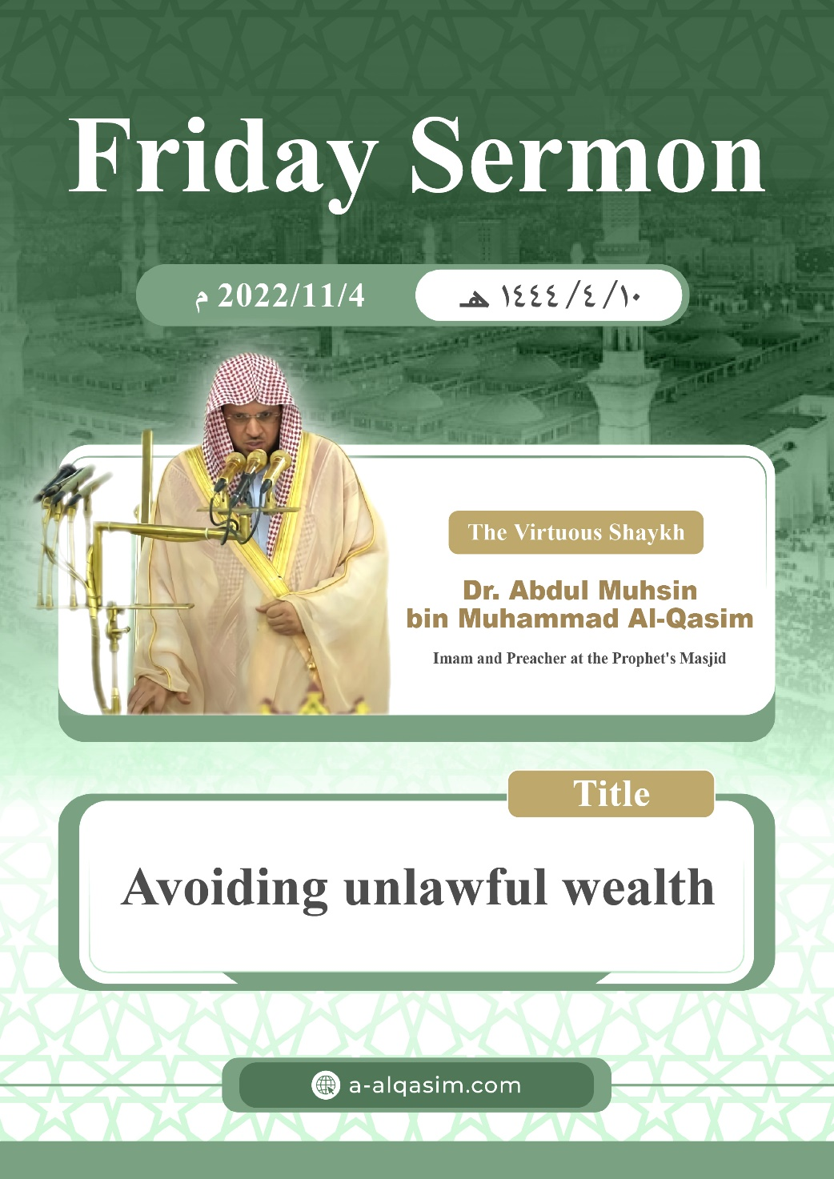

**Avoiding unlawful wealth ([1])**

Verily, all praise is for Allah. We praise Him, seek His aid and His forgiveness. We seek refuge in Allah from the evil of our souls, and from our bad deeds. Whomsoever Allah guides none can misguide, and whomsoever Allah leaves to go astray none can guide. I testify that there is none worthy of worship except Allah, alone with no partners. And I testify that our Prophet Muhammad is His slave and messenger. May Allah's peace and blessings be upon him, his family and his companions in abundance.

Amma ba'd (To proceed):

O slaves of Allah! Fear Allah as He deserves to be feared, and be conscious of Him in secret and in open.

Ayyuhal Muslimoon (O Muslims!)

Wealth is a great blessing from Allah through which life is made comfortable, difficulties are relieved, needs are fulfilled, and praiseworthy actions are performed. The Prophet ﷺ said, "**How excellent is good wealth for a good man!**" (Narrated by Al-Bukhari in al-adab al-mufrad). People's lives cannot be sustained except by wealth, and this is why it was beautified to them and made dear to their souls.

Allah (may He be exalted) said:

{ﲐ ﲑ ﲒ ﲓ ﲔ ﲕ ﲖ ﲗ ﲘ ﲙ ﲚ ﲛ ﲜ ﲝ ﲞ ﲟﲠ ﲡ ﲢ ﲣ ﲤﲥ ﲦ ﲧ ﲨ ﲩ}

{The enjoyment of [worldly] desires — women, children, treasures of gold and silver, fine horses, cattle, and fertile land – has been made appealing to people. These are the pleasures of this worldly life, but with Allah is the finest destination.} [Aal Imraan: 14]

Everything that is on Earth which is good and pure then the basic principle is that it is permissible for the creation, so that they can use it in the obedience of Allah. Allah (may He be exalted) said:

{ﳓ ﳔ ﳕ ﳖ ﳗ ﳘ ﳙ ﳚ ﳛ ﳜﳝ }.

{He [i.e. Allah] subjected for you whatever is in the heavens and whatever is on the earth—all by His grace.} [Al-Jaathiyah: 13]

The way of the messenger and their followers is to take that which is lawful, and consume that which is pure.

{ﲑ ﲒ ﲓ ﲔ ﲕ ﲖ ﲗﲘ}.

{O messengers! Eat from what is good and lawful, and act righteously.} [Al-Mu'minoon: 51]

Allah tested all of the previous nations with trials, and the trial of this nation is wealth. The Prophet ﷺ said, "**Every nation had a trial, and the trial of my nation is wealth.**" (Narrated by Ahmad).

The slave will be asked about how he earned and spent his wealth. The Messenger ﷺ said, "**The slave's feet will not move on the Day of resurrection until he is asked about how he spent his life, how he earned and spent his wealth, and how he wore out his body.**" (Narrated by At-Tirmidhi).

Financial dealings with people are a scale for a person's character and a matter in which people compete in performing good[2]. If person deals with people financially, and they attest to his truthfulness and trustworthiness, this is a proof of his high intellect and complete practice of the religion.

The slaves' rights between themselves are based on every person seeking his own rights. Therefore, Allah prohibited his slaves from consuming each others wealth unjustly, because doing so fuels hatred and enmity [between them]. Allah (may He be glorified) said:

{ﲋ ﲌ ﲍ ﲎ ﲏ}.

{Do not consume one another's wealth illegally.} [Al-Baqarah: 188]

And the sanctity of wealth is like the sanctity of blood and honour. The Prophet ﷺ delivered a sermon on the Day of sacrifice at Mina, in which he said, "**Indeed your blood, your wealth, and your honour are sacred for one another like the sanctity of this day of yours, in this month of yours, in this city of yours [i.e. Makkah].**" (Agreed upon).

Financial dealings with others are from the foundational things which are permissible that people cannot do without in their lives. However, their benefit and enjoyment by this cannot be achieved except by honesty and trustworthiness.

Shaytan has many ways in which he intervenes in people's financial dealings in order to make them fall into what is forbidden for them. The texts [of the Quran and Sunnah] have come with a stern warning for he who falls into the Shaytan's trap, and consumes the wealth of others unlawfully in any way.

Honestly and clarity are the basis for dealings between people. The Prophet ﷺ said, "**The buyer and seller have the choice [of nullifying the transaction] so long as they have not separated. If they are truthful and clarify [the defects of the commodity] their transaction will be blessed [by Allah].**" (Agreed upon). As for he who violates them by selling his brother something forbidden, or something he does not own or possess the right to benefit from[3], or something he is unable to deliver, then he has surely fallen into what he was forbidden from.

A transaction which involves deception or obscurity, as well as cheating in selling are all matters concerning which a warning has come [in the texts of the Quran and Sunnah]. Abu Hurayrah (may Allah be pleased with him) said: "The Messenger of Allah ﷺ passed by a heap of wheat. He put his hand inside it, and his fingers were moistened. So he said to the owner: '**What is this?!**' He replied: 'This was caused by the rain, O Messenger of Allah'. The Prophet ﷺ said: **'Why did you not place this part at the top so that the people could see it? He who deceives is not from me.'**" (Narrated by Muslim).

The believers are a single united body, and from that which disunites them is blameworthy competition in wealth. Therefore, he who undercuts his brother, or increases the price of a commodity [by bidding] – even though he does not want it – has committed a forbidden act. The Prophet ﷺ said, "**Do not envy one another. Do not inflate prices for one another [by outbidding each other to raise the price]. Do not hate one another. Do not boycott one another. Do not undercut one other in trade.**" (Agreed upon).

Allah (may He be glorified) is Al-‘Adheem (The Greatest). An oath is not taken by his name except in a matter which is great. The believer avoids taking oaths in financial dealings. For he who swears by Allah truthfully to encourage people to buy a commodity, will have the blessings from his wealth removed. The Prophet ﷺ said: "**Oaths may persuade the buyer to purchase the goods, but it takes away the blessing.**" (Agreed upon). As for he who swears by Allah dishonestly to promote a commodity amongst people, then he has combined between three extremely terrible actions: Lying, belittling Allah and deceiving the buyer.

Abu Dharr (may Allah be pleased with him) narrated that The Prophet ﷺ said: "**There are three [types of] people to whom Allah will neither speak to on the Day of Resurrection, nor look at them nor purify them, and they will have a painful chastisement**." The Messenger of Allah ﷺ repeated this three times. Abu Dharr (May Allah be pleased with him) remarked: 'They are ruined, and they have lost. Who are they, O Messenger of Allah?' The Messenger of Allah ﷺ replied, "**The one who lowers his garments below his ankles, the one who reminds others of his favours; and the one sells his goods by taking a false oath.**"

Fulfilling contracts, keeping covenants, and people fulfilling the conditions they have stipulated is one of the excellent qualities of the religion that Allah has commanded. Allah (may He be exalted) said:

{ﱺ ﱻ ﱼ ﱽ ﱾﱿ}.

{O you who have believed! Fulfil your contractual obligations [including promises, covenants, oaths, etc.]} [Al-Maaidah: 1]

The Prophet ﷺ said, "**Muslims must abide by their conditions, except for a condition which makes unlawful something which is lawful, or makes lawful something which is unlawful.**" (Narrated by At-Tirmidhi).

The buyer deserves what he paid for in full. As for the one who fraudulently gives the buyer less than what he is due, then Allah has promised him with loss and destruction. Allah (may He be exalted said):

{ﲥ ﲦ * ﲨ ﲩ ﲪ ﲫ ﲬ ﲭ * ﲯ ﲰ ﲱ ﲲ ﲳ}.

{Woe to *Al-Mutaffifin*. Those who take full measure [when they buy] from people, but give less when they measure or weigh for buyers.} [Al-Mutaffifin: 1-3]

The consumer of interest takes more than what he is entitled to, and as he shows his power to the poor [by wrongfully forcing them to pay interest], Allah al-Qawiy (the All-Powerful) wages war against him. Allah (may He glorified said):

{ﲕ ﲖ ﲗ ﲘ ﲙ ﲚ ﲛ ﲜ ﲝ ﲞ ﲟ ﲠ ﲡ * ﲣ ﲤ ﲥ ﲦ ﲧ ﲨ ﲩ ﲪﲫ}.

{O you who have believed, fear Allah and give up what remains [due to you] of interest, if you are [true] believers. And if you do not, then be informed of a war [against you] from Allah and His Messenger.} [al-Baqarah :278-279]

In addition to this, he is threatened with being cursed. Jabir (may Allah be pleased with him) said, "The Messenger of Allah ﷺ cursed the one who consumes interest, the one who pays it, the one who writes it, and those who witness it. And he [i.e. the Prophet ﷺ] said: '**They are all the same.**'" (Narrated by Muslim).

The worker should have the qualities of strength and trustworthiness. Allah (may He be exalted) said:

{ﲞ ﲟ ﲠ ﲡ ﲢ ﲣ}.

{Verily, the best man for you to hire is the strong and trustworthy [one[.} [Al-Qasas :26]

Whoever falsely claims to know a craft, and uses this to take people's money from them has tricked them by faking [a quality within himself] that he does not possess. The Prophet ﷺ said, "**The one who creates a false impression of receiving what one has not been given is like one who wears two garments of falsehood.**" i.e. in dispraise. (Agreed upon).

Allah (may He be glorified) is the opponent of the oppressive, and He has explicitly stated that He is an opponent to three [types of people] because of the ugliness of their affair. From them is the one who prevents the servant and worker of their rights [such as their salary], or delays in fulfilling it to them unjustly. The Prophet ﷺ said, "**Allah said, 'I will be an opponent to three types of people on the Day of resurrection: A man who makes a covenant by Me, and then acts treacherously, [also] a man who sells a free person and consumes his price, and a man who employs a worker, who completes the work in full, but does not pay him his wages.**'" (Narrated by Al-Bukhari).

Whoever does good to someone else, and gives him a loan is deserving of thanks and gratitude. The debtor who does not pay back his debt or delays in doing so – even though he has the ability – has wronged the creditor, denied his kindness, and consumed someone else's wealth unjustly. The Prophet ﷺ said, "**Delay in paying debts by a wealthy man is injustice.**" (Agreed upon).

The rights of the creation are based on giving each person his due right, and preventing what a person wants if he does not deserve it. Those who give and take bribes are exposed to Allah's curse. Abdullah ibn Amr (may Allah be pleased them both) said: "The Messenger of Allah ﷺ cursed the one who gives bribes, and the one who takes them."

Whoever assumes a position of authority, and accepts people's gifts [due to that authority] has taken them unjustly, and he will meet Allah carrying them. Abu Humayd as-Saidi (May Allah be pleased with him) said, "The Messenger of Allah ﷺ appointed a man called Ibn al-Lutbiyya to collect the Zakat from [the tribe of] Bani Sulaym. When he came, the Prophet ﷺ called him to account. He said [to the Prophet], 'This is your wealth, and this has been given to me as a gift'. So the Messenger of Allah ﷺ said, '**If only you had stayed in your father's and mother's house to see whether you will be given gifts or not if you are telling the truth?**' Then the Prophet ﷺ said: '**I employ a man from among you to manage some matters from what Allah has put under my custody, and then he comes to me and says, 'This is your money, and this has been given to me as a gift. Why did he not stay in his father's and mother's house to see whether he will be given gifts or not? By Allah, none of you takes a thing unlawfully but he will meet Allah on the Day of resurrection, carrying that thing.**' Then the Prophet [ﷺ] raised his hand till the whiteness of his armpits became visible, and he said, '**O Allah! Have I conveyed [Your message]?'**" (Agreed upon).

Trustworthiness is from that which the Prophet ﷺ enjoined at the beginning of his prophethood. Hiraql said to Abu Sufyan (may Allah be pleased with him), "What does he [i.e. the Prophet ﷺ] command of you?" Abu Sufyan replied, "He commands us to worship Allah alone, and not associate any partners with him, and he forbids us from that which our fathers used to worship. He commands us to pray, give charity, be chaste, and fulfil our covenants and trusts." (Narrated by Al-Bukhari). It is from that which the slave will be held accountable for on the Day of resurrection in the most difficult of situations. Due to the importance of its affair and the great care in its rights, it will appear near the Sirat[4]. The Prophet ﷺ said, "**Trustworthiness and the ties of kinship will be sent forth and will stand on the sides of the Sirat, right and left.**" (Narrated by Muslim).

The supervisor of the Muslims' endowments that does not actively seek what is most beneficial for them, or consumes more than what was assigned to him, or forbids a deserving person, or violates the conditions of the endowers has surely neglected what he has been entrusted with, and your Lord is watchful over him.

The one who does not fulfil the bequest of his deceased relative, or delays in executing it, or violates it, or hides from it that what would reduce his portion: has surely oppressed the deceased, and Allah is an observer over him.

The guardian of the orphans and the weak if he deals with them unjustly, or prevents them from their rights has been oppressive to them. Allah (may He be glorified) said:

{ﱴ ﱵ ﱶ ﱷ ﱸ ﱹ ﱺ ﱻ ﱼ ﱽ ﱾﱿ ﲀ ﲁ}.

{Indeed, those who unjustly consume the wealth of orphans consume nothing but fire into their bellies. And they will be burned in a blazing Hell!} [An-Nisaa: 10]

Whoever has been entrusted with or lent something, and then denies this, or is negligent in preserving it and damages it, or he rents something and ruins it, or is entrusted by some people in a transaction, and he betrays them, then he has surely consumed wealth unlawfully. And the one who denies is like the thief. Aishah (may Allah be pleased with her) said, "A woman from the tribe of Makhzum used to borrow things [from people] and then denied [having taken them], so the Messenger of Allah ﷺ commanded that her hand be cut off." (Narrated by Muslim(.

Whoever deprives an inheritor from his portion of the inheritance, or decreases or hides from it has surely consumed something forbidden. The Prophet ﷺ said, "**Give the shares [of inheritance] to those who are entitled to them.**" (Agreed upon).

Whoever abuses a weak person – be it the mother, wife, or daughter – by his strength and guardianship, and he takes their money, let him remember Allah's power over him. The Prophet ﷺ said, "**It is not permissible to take the wealth of a Muslim except with his consent.**" (Narrated by Ahmad).

Whoever illegally takes possession of a piece of land, or changes its boundaries will be recompensed in a similar manner. The Prophet ﷺ said, "**Whoever wrongs another with regard to a handspan of land will be encircled with it down through seven earths.**" (Agreed upon).

Whoever takes from the right of a Muslim – even a little amount – Allah will obligate Hellfire for him. The Prophet ﷺ said, "**Whoever misappropriates the right of a Muslim by means of a ]false[ oath, Allah would decree Hell-fire for him and forbid Paradise to him.**" A man said to him: "O Messenger of Allah, even if it is something insignificant?" He said: "**Even if it is the twig of the arak tree.**" (Narrated by Muslim).

The one who asks people for their wealth without any need has only asked for live coals. The Messenger ﷺ said, "**He who asks others for their wealth in order to increase his own is asking only for live coals, so let him ask a little or much.**" (Narrated by Muslim).

Every transaction between people that involves oppression, harm, deception, or preventing that which Allah has obligated, or doing that which He has prohibited falls under consuming wealth unjustly.

That which is forbidden has a boundary of doubtful matters, and it is feared for the one that goes beyond this boundary [and falls into that which it doubtful] that he will fall into that which is prohibited. And he who avoids the doubtful matters and stays clear of them has protected his honour and saved his religion.

The Muslim is he who the Muslims are safe from his tongue and hand, and he leaves this world without having any dispute between him and any other Muslim regarding their souls [i.e. by harming them] or wealth. The Prophet ﷺ said, "**Verily I hope to meet Allah, and none of you are seeking [recompense from] me for an injustice involving blood or wealth.**" (Narrated by Ahmad).

Wa ba'd ayyuhal muslimoon (To conclude, O Muslims!)

Unlawful wealth – even if it is abundant – is void of blessing. It brings calamities, prevents happiness, angers Ar-Rabb (The Lord), and if the servant raises his hands [in supplication] his supplication will not be answered.

The wise person is he who places wealth in his hand, and not in his heart, and is conscious of Allah regarding it. Rifaa'ah (May Allah be pleased with him) went out with the Prophet ﷺ to the prayer place, and he saw the people trading, so he said, "**O merchants!**" They answered the Messenger of Allah ﷺ turning their necks and gazes towards him, and he said, "**Indeed the merchants will be resurrected on the Day of judgement as evil-doers, except the one who has consciousness of Allah, and is pious and truthful**." (Narrated by At-Tirmidhi)

On the other hand, lawful wealth – even it is little – becomes plentiful with contentment, and it is better for the slave than competing in wealth without any caution or guidance from Allah. The Prophet ﷺ said, "**By Allah, I do not fear poverty for you, but I fear that worldly wealth will be given to you in abundance as it was given to those before you. So you will compete amongst yourselves for it as they competed for it, so it will destroy you as it destroyed them.**" (Agreed upon).

A'udhu billahi minash-shaytanir-rajeem

I seek refuge in Allah from the accursed Shaytan.

{ﱙ ﱚ ﱛ ﱜ ﱝ ﱞ ﱟ ﱠ ﱡ ﱢ ﱣ ﱤ ﱥ ﱦ ﱧﱨ}

{O you who have believed, do not consume one another's wealth illegally, but rather trade by mutual consent} [An-Nisaa :29]

May Allah bless me and you by The Great Quran.

**The second sermon**

All praise is for Allah for His excellence and kindness, and gratitude is due to Him for his guidance and favours. I testify that there is none worthy of worship except Allah alone having no partners; glorifying Him, and I testify that Muhammad is His slave and messenger, may Allah's peace and blessings be upon him, and his family and companions in abundance.

Ayyuhal Muslimoon (O Muslims!)

Lawful wealth is abundant and pure, and Allah (may He be exalted) is the Lord of all that which is pure. Whoever observes Allah's boundaries in that which He gives him, and fulfils his rights in that which He has provided, Allah will bless and honour him. He will answer his supplication. He will bless him in the small amount of his wealth and increase him in his sustenance.

And whomsoever Allah gives to him lawful wealth, which he uses for His obedience and avoiding sins, then verily he has been given that which the righteous will envy[5] him for.

The Prophet ﷺ said, "**There should not be any envy except towards two men. A man who has been given [knowledge of] the Quran, and he recites it during the night. And a man who has been given wealth, so he spends it in charity during the night and day.**"

The person who is truly bankrupt is not the one who misses out on being rich because of the lack of his wealth. Rather, the truly bankrupt person is he who misses out on gaining good deeds and leaving bad deeds, and consumes the wealth of others unjustly, and wrongfully indulges in their blood and honour.

Thereafter, know that Allah has commanded you to invoke His peace and blessings upon His Prophet…

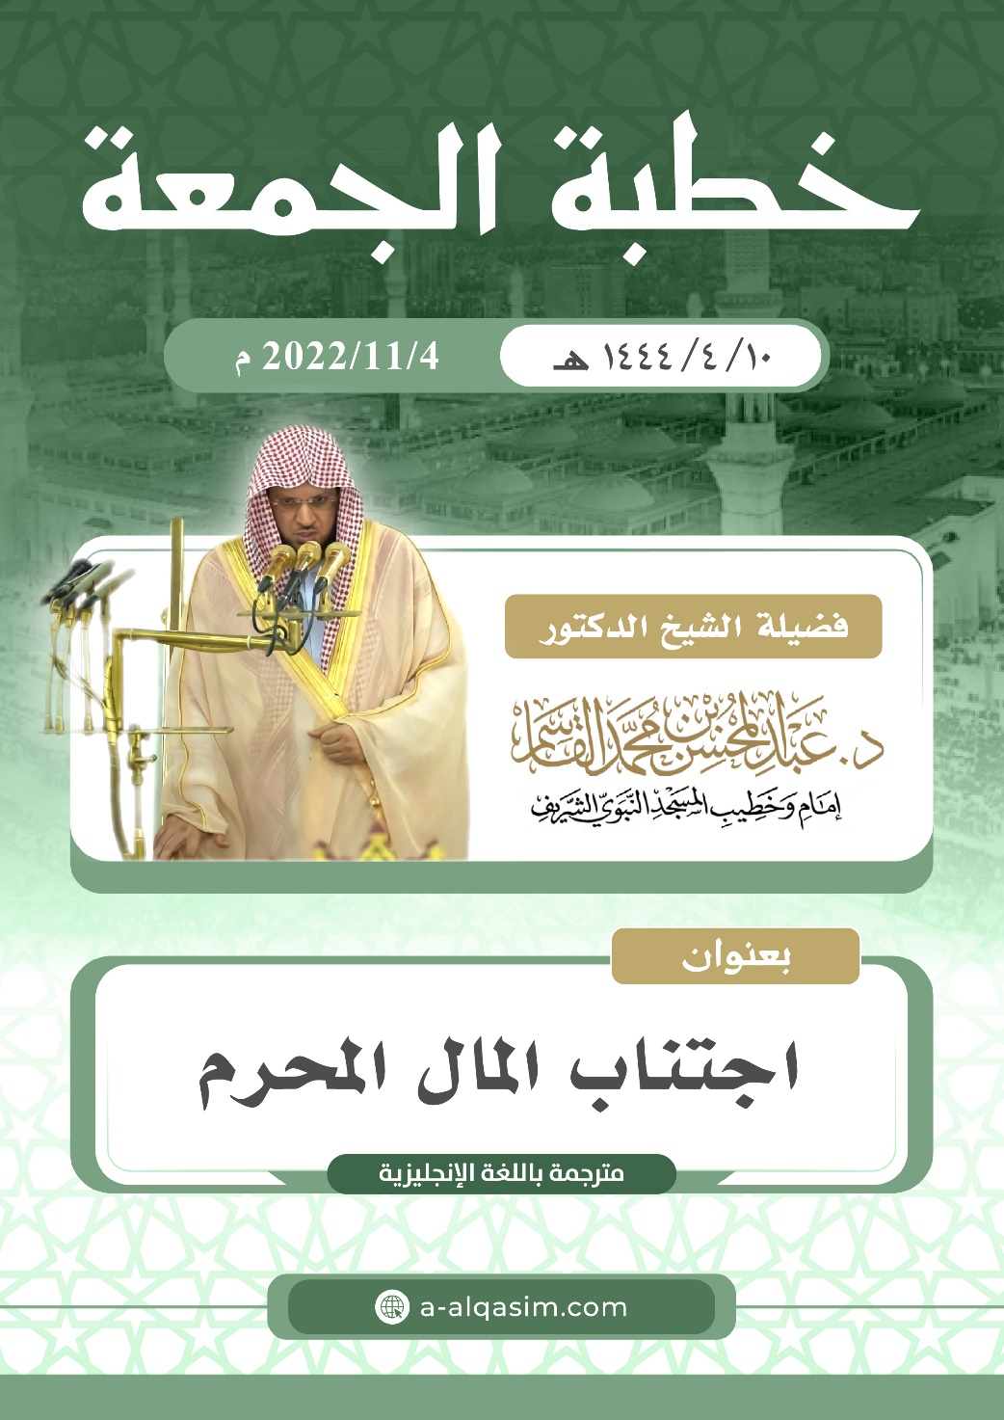

1. This sermon was delivered on Friday the 27th of Rabi-al-Awwal 1444AH, in Al-Masjid An-Nabawi.
2. [Translator's note: by giving charity for example, to gain Allah's pleasure]
3. [Translator's note: i.e. this object is owned by him, but it is a security for a loan that he has taken out for example.]
4. [Translator's note: The Siraat is a bridge that will be set up over Jahannam over which people will pass – according to their deeds – to reach Jannah.]
5. [Translator's note: this is not the dispraised envy in which a person hopes for the removal of blessings from his brother. This type of envy refers to hoping for something similar to what he has, such that a person can perform good like he is doing it.]