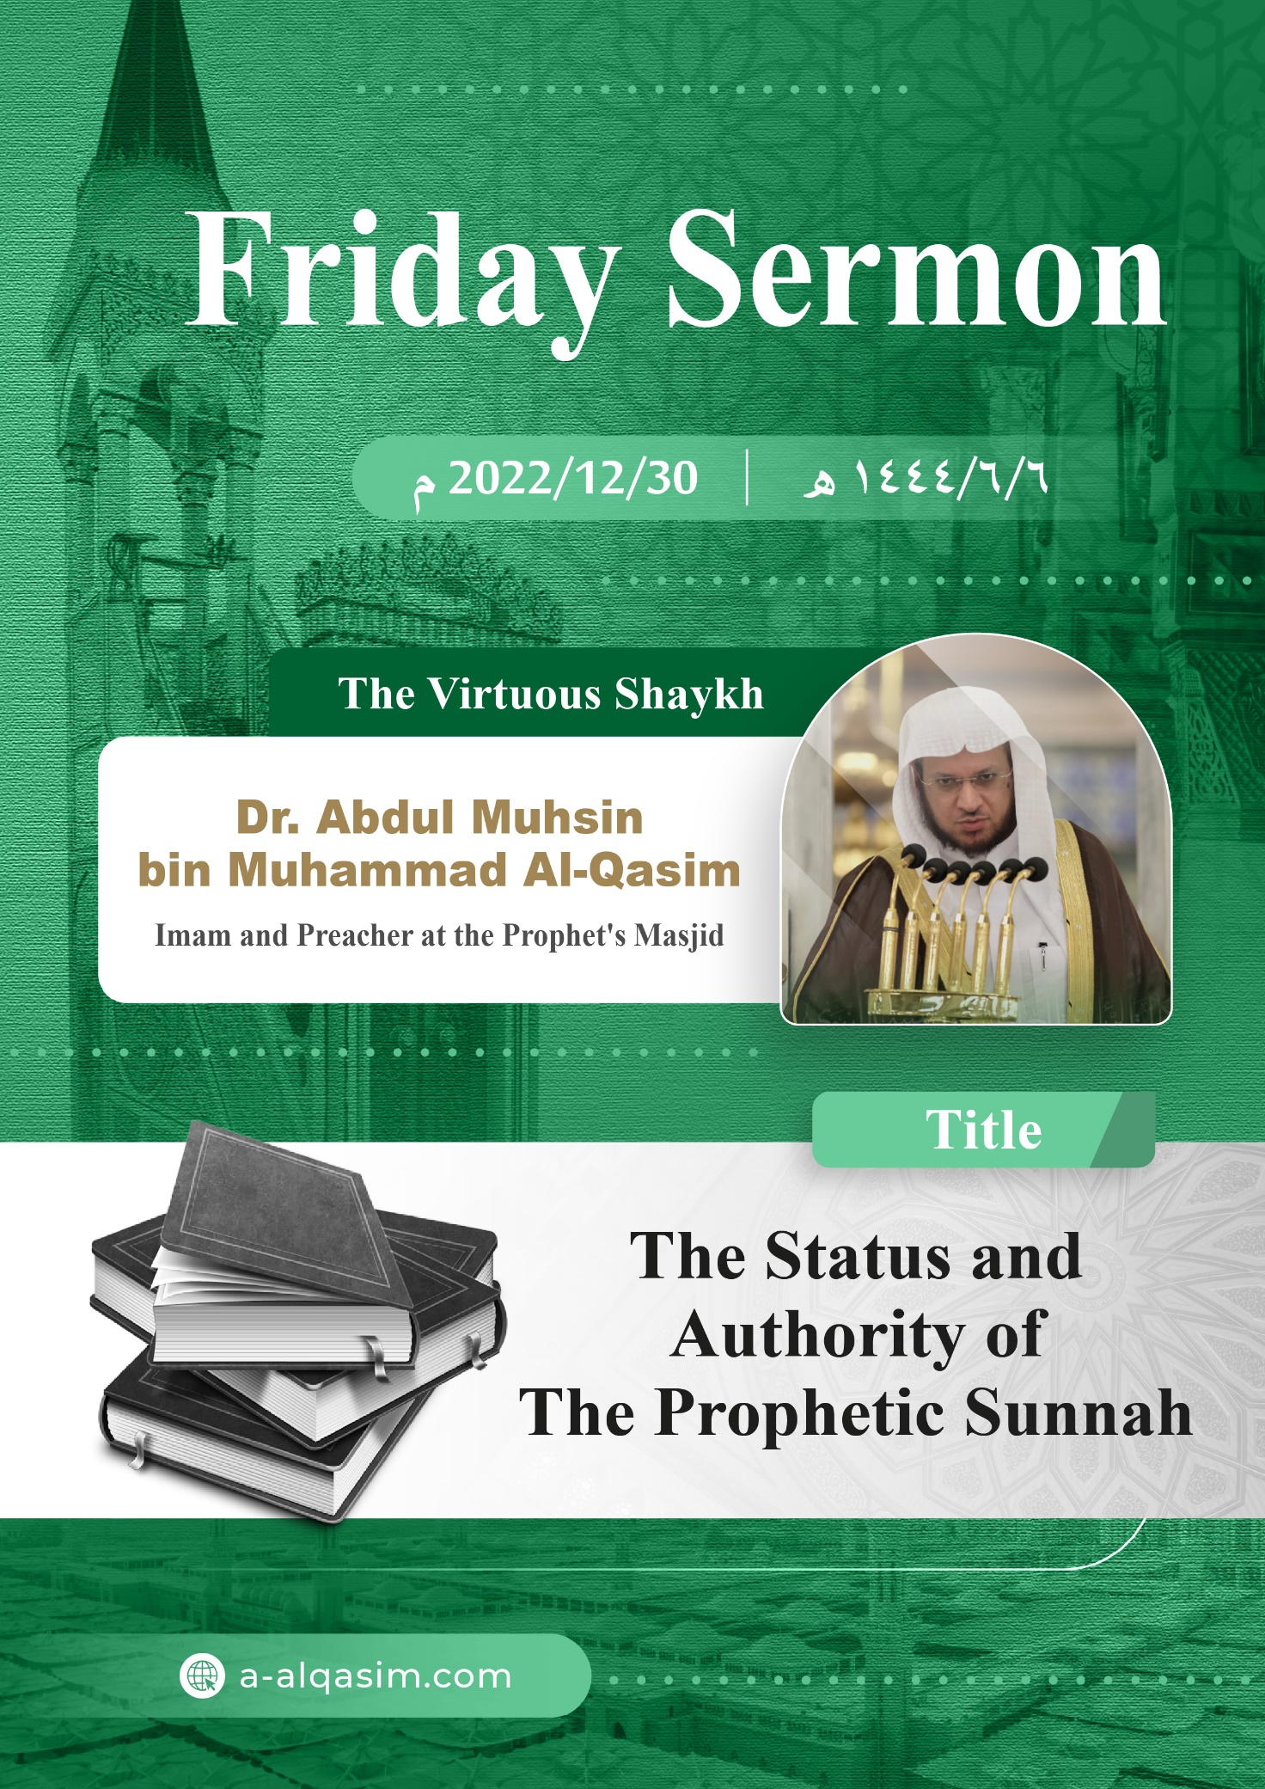

**(The Status and Authority of the Prophetic Sunnah) ([1])**

Verily, all praise is for Allah. We praise Him, seek His aid and His forgiveness. We seek refuge in Allah from the evil of our souls, and from our bad deeds. Whomsoever Allah guides none can misguide, and whomsoever Allah leaves to go astray none can guide. I testify that there is none worthy of worship except Allah, alone with no partners. And I testify that our Prophet Muhammad is His slave and messenger. May Allah's peace and blessings be upon him, his family and his companions in abundance.

Amma ba'd (To proceed):

O slaves of Allah! Fear Allah as He deserves to be feared, and be conscious of Him in secret and in open.

Ayyuhal Muslimoon (O Muslims!)

Allah sent His Messenger Muhammad with guidance and the religion of truth, at a time when there were no messengers or books, words were distorted [from their proper meanings] and [previous] legislations had been changed. Thus, the earth was [illuminated] by his message, and shone after its darkness. Through it, hearts were united after their separation [and disunity]. He placed guidance and success in following the Prophet ﷺ, and He placed misguidance and misery in disobeying him.

His Lord sent him with the most complete of His messages, the best of His Books, and His final legislation; as a proof against the creation, and to cut off any excuses. He came from his Lord with the light of revelation which eradicates every darkness, and through it the souls have life. Allah (may He be exalted) said:

{ﲇ ﲈ ﲉ ﲊ ﲋ ﲌ ﲍ ﲎ ﲏ ﲐ ﲑ ﲒ ﲓ ﲔ ﲕ ﲖ ﲗ ﲘﲙ}

{Can those who had been dead, to whom We gave life and a light with which they can walk among people, be compared to those in complete darkness from which they can never emerge?} [Al-An'aam: 122]

The details of guidance to the truth and to good are not known except through divine revelation.

{ﱁ ﱂ ﱃ ﱄ ﱅ ﱆﱇ ﱈ ﱉ ﱊ ﱋ ﱌ ﱍ ﱎ ﱏ ﱐ ﱑ ﱒ ﱓ ﱔ ﱕ ﱖ ﱗﱘ}

{And so We have revealed to you [O Prophet ﷺ] a revelation of Our command [i.e. the Quran]. You did not know what the Book is, nor [what is] faith, but We have made it a light by which We guide whoever We will of Our slaves.} [Ash-Shooraa: 52]

The Sunnah is divine revelation just like the Quran. Ar-Rooh Al-Ameen (The Trustworthy Spirit) Jibreel (peace be upon him) came down with it to the Prophet Muhammad ﷺ. Allah (may He be exalted) said:

{ﳂ ﳃ ﳄ ﳅ ﳆ ﳇ ﳈ ﳉ ﳊ ﳋﳌ}

{Allah has revealed to you the Book and wisdom and taught you what you did not know.} [An-Nisaa: 113]

'Wisdom' here refers to the Sunnah by the unanimous agreement of the Salaf (the predecessors).

Therefore, the statements and actions of the Prophet ﷺ are all correct and true. Allah (may He be exalted) said:

{ﱁ ﱂ ﱃ * ﱅ ﱆ ﱇ ﱈ ﱉ * ﱋ ﱌ ﱍ ﱎ *   
ﱐ ﱑ ﱒ ﱓ ﱔ *}

{By the stars when they fade away! Your companion [Prophet Muḥammad ﷺ] has not strayed, nor has he erred. Nor does he speak of his own whims and desires. It is only a revelation sent down [to him].} [An-Najm: 1-4]

The Hadeeth of the Prophet ﷺ is in agreement with intellect and fundamental principles. It is not denied by the intellectual [person] who knows the position that Allah has placed His Messenger ﷺ at in the religion nor [do they deny] the obligation He has made upon the people to his [the Messenger’s] obedience. The heart of one who has firm belief in the truth of what he says does not repel it and [accepts] the following of what he has ruled with.

Allah (may He be glorified) revealed two revelations to His Messenger: the Book [i.e. the Quran], and the Sunnah. They are similar in their usage as evidence. Allah obligated upon His slaves to believe in them both, and according to what is in them both. Whoever differentiates between them and claims that the Quran is suffices him in the matters of the religion, is like the one who believes in part of the Book and disbelieves in part of it. Therefore, following one of them is [in reality] following the other. The Book and the Messenger ﷺ never contradict each other, just as the Book does not contradict itself. Allah (may He be exalted) said:

{ﱯ ﱰ ﱱ ﱲ ﱳ ﱴ ﱵ ﱶ ﱷ ﱸ}

{Had it been from anyone other than Allah, they would have certainly found in it many contradictions.} [An-Nisaa: 82]

Therefore, whatever the Messenger of Allah commanded or forbade is like what Allah [himself] commanded or forbade. The Prophet ﷺ said, "**One of you almost rejects me whilst reclining on his couch. He narrates a hadeeth from me, and he says, 'Between us and you is the Book of Allah: what it says is permissible, we take as permissible, and what it says is forbidden, we take as forbidden. But verily, whatever the Messenger of Allah forbids is like what Allah forbids.**" (Narrated by Ahmad). Ash-Shawkani (may Allah have mercy on him) said, "The affirmation of the pure Sunnah's authority, and its independence in legislating rulings is a religious necessity. No one differs in it except for the one who has absolutely no portion in the religion of Islam."

Allah protected His Prophet ﷺ in his statements and actions, and guarded him from the plots of his enemies, so he could convey the message completely.

{ﱪ ﱫ ﱬ ﱭ ﱮ ﱯ ﱰ ﱱﱲ ﱳ ﱴ ﱵ ﱶ ﱷ ﱸﱹ ﱺ ﱻ ﱼ ﱽﱾ}

{O Messenger! Convey that which been revealed to you from your Lord. If you do not, then you have not delivered His message. Allah will protect you from the people.} [Al-Maaidah: 67]

Aaishah (may Allah be pleased with her) said, "Whoever informs you that Muhammad ﷺ concealed part of what was revealed to him has surely lied. Allah says:

{ﱪ ﱫ ﱬ ﱭ ﱮ ﱯ...}

{ O Messenger! Convey that which been revealed to you from your Lord…} [Al-Maaidah: 67] [to the end of] the verse." (Agreed upon).

Al-Awza'i (may Allah have mercy on him), "When a hadeeth from the Messenger of Allah ﷺ reaches you, beware of differing with it. For indeed, the Messenger of Allah ﷺ was a conveyer from Allah (may He be exalted)."

The Prophet ﷺ called the slaves towards Paradise. A group of angels gave an example of the Prophet ﷺ by saying, "His example is that of a man who has built a house and then offered therein a banquet and sent a messenger to invite the people. So whoever accepted the invitation of the messenger, entered the house and ate from the banquet, and whoever did not accept the invitation of the messenger, did not enter the house, nor did he eat from the banquet." Then they said, "The house stands for Paradise, and the caller is Muhammad ﷺ; and whoever obeys Muhammad ﷺ, obeys Allah; and whoever disobeys Muhammad ﷺ, disobeys Allah. Muhammad separated the people [i.e., through his message, the good are distinguished from the bad and the believers from the disbelievers]." (Narrated by Al-Bukhari).

The Sunnah of the Prophet ﷺ is a clarification and explanation of the Quran. Through the Sunnah, what has been summarised in the Quran is known [more elaborately], and the details of legislation are taken from it. Through the authentic Prophetic Sunnah, the verses of the Quran and what Allah intended by them is understood correctly.

The verses of the Book are understood correctly through to it. Allah (may He be exalted) said:

{ﱕ ﱖ ﱗ ﱘ ﱙ ﱚ ﱛ ﱜ ﱝ ﱞ}

{And We have revealed to you [O Prophet ﷺ] the Reminder, so that you may explain to the people what has been revealed to them, and perhaps they will reflect.} [An-Nahl: 44]

The Prophet ﷺ informed his Companions and the rest of his ummah of their Deity and God in a complete manner, to the point where it is as if they see Him in His attributes of perfection and honour. He informed them of the [other] Prophets, their nations, and what happened to them, until it is as if they were in their midst. He informed them of the paths of good and bad – the small and big – that which no prophet before him informed his nation.

If it were not for the Sunnah of the Prophet ﷺ, the Muslim would not be guided to the number of units in the Salah, the portions of the Zakah, the description of Hajj and Umrah, the rulings of financial transactions and marriage, and other details regarding the religion. Abdullah ibn Umar (may Allah be pleased with them) said, "Verily, Allah sent Muhammad ﷺ and we did not know anything. We only do as we saw him do." A man came to Imran ibn Husayn (may Allah be pleased with them) and asked him something, so he answered. Then the man said, "Inform [me] from Allah's Book, and do not inform [me] from anything other than it." Then, Imran (may Allah be pleased with him) said, "In Allah's Book do you find that the Zhuhr prayer consists of four units in which the recitation is silent? Or [do you find] the number of the prayers and the numbers [related to the details] of Zakah, and other such matters?" Then he said, "Do you find this explained in Allah's Book? Verily Allah has ruled with all of that, and the Sunnah is what explains it." Shaykh Al-Islam Ibn Taymiyyah (may Allah have mercy on him) said, "The Sunnah explains the Qur’an, clarifies it, refers to it and expresses [matters that the Qur’an has discussed]."

The Prophet ﷺ came with the good of this world and the Hereafter in its entirety. He did not make the Creation require anyone other than him in clarification [of their Lord's commands and prohibitions]. For this [reason], the Prophet ﷺ encouraged his ummah to memorise his Sunnah and to convey it to the Creation. He ﷺ said, "**Let those who are present convey to those who are absent. For perhaps the one to whom it is conveyed will understand it better than the one who hears it.**" (Agreed upon).

It is obligatory upon the slaves to take everything that the Prophet ﷺ came with. It is also obligatory for them to abstain from everything which he forbade or warned from. Allah (may He be exalted) said:

{ﲐ ﲑ ﲒ ﲓ ﲔ ﲕ ﲖ ﲗﲘ}

{Whatever the Messenger gives you, take it. And whatever he forbids you from, leave it.} [Al-Hashr: 7]

The slave does not reach true faith except when certainty fills his heart, by him believing the Prophet ﷺ in everything that he came with, not hesitating in obeying any of his commands, and not finding any resistance within himself against submitting to what he informed of. Allah (may He be exalted) said:

{ﲜ ﲝ ﲞ ﲟ ﲠ ﲡ ﲢ ﲣ ﲤ ﲥ ﲦ ﲧ ﲨ ﲩ ﲪﲫ ﲬ ﲭ ﲮ}

{The believers are only the ones who have believed in Allah and His Messenger, then do not doubt; and they strive with their wealth and their lives in the cause of Allah. It is those who are the truthful.} [Al-Hujuraat: 15]

Rather, the slave's faith is not valid until he seeks the judgment of his legislation and Sunnah, and what he brought in every small and large matter of the religion whilst he is happy with his ruling and does not find any resistance within himself against it; and he submits to his command completely. Allah (may He be exalted) said:

{ﲬ ﲭ ﲮ ﲯ ﲰ ﲱ ﲲ ﲳ ﲴ ﲵ ﲶ ﲷ ﲸ ﲹ ﲺ ﲻ ﲼ ﲽ ﲾ}

{But no! By your Lord, they will never be [true] believers until they accept you [O Prophet ﷺ] as the judge in their disputes, and find no resistance within themselves against your decision and submit wholeheartedly.} [An-Nisaa: 65]

Allah (may He be exalted) sent the Messenger ﷺ to us by His grace, in order for us to follow him. The Rightly Guided Caliphs would not give precedence to anyone's speech over the Sunnah of the Prophet ﷺ. Uthmaan (may Allah be pleased with him) said, "I would not leave the Sunnah of Allah's Messenger ﷺ for the statement of anyone." The Imams are indisputably agreed upon the obligation of following the Messenger, and the nurturing scholars were upon this upright methodology. Ash-Shafi'i (may Allah have mercy on him) said, "The Muslims have unanimously agreed that it is not permissible for a person to whom the Sunnah of Allah's Messenger ﷺ has become clear, to leave it for the statement of anyone."

Therefore, it is obligatory upon the slave to follow the Prophet ﷺ in all of his affairs. Allah (may He be exalted) said:

{ﱾ ﱿ ﲀ ﲁ ﲂ ﲃ ﲄ ﲅ ﲆﲇ}

{O you who have believed, do not put [yourselves] before Allah and His Messenger} [Al-Hujuraat: 1]

Ibn Katheer (may Allah have mercy on him) said, "i.e. do not rush in making decisions before him. Rather, follow his lead in all matters."

Every matter that opposes the Sunnah of the Prophet ﷺ contains no good for the slave. Sufyan ibn Uyaynah (may Allah have mercy on him) said, "Verily, the Messenger of Allah ﷺ is the greatest scale. Things are presented against him; his character, his life and his way. Whatever accords to them is the truth, and whatever opposes them is falsehood."

Opposing his command necessitates disgrace in this world and the Hereafter. The Messenger of Allah ﷺ said, "**Disgrace and humiliation have been placed on the one who opposes my command.**" (Narrated by Ahmad). It is also a reason for loss and an evil ending.

{ﲛ ﲜ ﲝ ﲞ ﲟ ﲠ ﲡ ﲢ ﲣ}

{And whoever does not believe in Allah and His Messenger, then We surely have prepared for the disbelievers a blazing Fire.} [Al-Fath: 13]

Whoever opposes the Sunnah of the Prophet ﷺ with a statement, action, intellect or analogy has not fulfilled what Allah has obligated upon him of venerating and honouring the Prophet ﷺ. Allah (may He be exalted) said:

{ﲪ ﲫ ﲬ ﲭ ﲮ * ﲰ ﲱ ﲲ ﲳ ﲴﲵ ﲶ ﲷ ﲸ * ﱁ ﱂ ﱃ ﱄ ﱅ ﱆ}

{Indeed, We have sent you [O Prophet Muhammad] as a witness, a bearer of good news, and a warner, so that you [people] may believe in Allah and His Messenger, support and honour him, and glorify Allah morning and evening. Surely those who pledge allegiance to you [O Prophet Muhammad ﷺ] are actually pledging allegiance to Allah} [Al-Fath: 8-10]

Whoever turns away from the Sunnah of the Prophet ﷺ, or arrogantly refrains from it, or doubts his speech or that which he came with, or objects to it with intellect or desires; will regret what he did of these things on the Day of Resurrection.

{ﱥ ﱦ ﱧ ﱨ ﱩ ﱪ ﱫ ﱬ ﱭ ﱮ ﱯ}

{On the Day their faces will be turned about in the Fire, they will cry, "Oh! If only we had obeyed Allah and obeyed the Messenger!"} [Al-Ahzaab: 66]

Whoever has any part of the Sunnah of the Prophet ﷺ become clear to him, then he knowingly leaves it off; this is from the deviation of his heart. Abu Bakr (may Allah be pleased with him) said, "I do not leave off anything that the Messenger of Allah ﷺ used to do. I fear that I would become deviated if I left off any of his commands." (Narrated by Al-Bukhari).

Whoever leaves off the Sunnah out of dislike for it, or preferring something else over it is deserving of a severe threat. The Messenger of Allah ﷺ said, "**Whoever turns away from my Sunnah is not from me.**" (Agreed upon). Shaykh Al-Islam (may Allah have mercy on him) said, "The hypocrisy mentioned in the Quran is hypocrisy to the Messenger ﷺ."

Nothing will bring people out of the darkness of confusion, and take them by the hand at times of trials and excessive differing between the people except for holding firm to the Sunnah of the Prophet ﷺ, and adhering to it in every situation. He ﷺ said, "**Whoever amongst you lives after me will see a lot of differing. Upon you is [to follow] my way, and the way of the Rightly Guided Caliphs after me. Hold on to it, and bite it with your molar teeth.**" (Narrated by Abu Dawood).

Following the Prophet ﷺ brings about Allah's love, and the forgiveness of sins. Allah (may He be exalted) said:

{ﱞ ﱟ ﱠ ﱡ ﱢ ﱣ ﱤ ﱥ ﱦ ﱧ ﱨﱩ ﱪ ﱫ ﱬ * ﱮ ﱯ ﱰ ﱱﱲ ﱳ ﱴ ﱵ ﱶ ﱷ ﱸ ﱹ}

{Say, [O Prophet Muhammad ﷺ], "If you [really] love Allah, then follow me; Allah will love you and forgive your sins. And Allah is Al-Ghafoor (The All-Forgiving) and Ar-Raheem (The Most Merciful)." Say, [O Prophet Muhammad ﷺ], "Obey Allah and His Messenger." If they still turn away, then truly Allah does not like the disbelievers.} [Aal-Imraan: 31-32]

Whoever obeys the Prophet ﷺ and follows his Sunnah has been promised Paradise. He ﷺ said, "**All of my ummah will enter Paradise except those who refuse.**" They said, "O Messenger of Allah, who would refuse?" He said, "**Whoever obeys me will enter Paradise and whoever disobeys me has refused.**" (Narrated by Al-Bukhari).

He died and there was not a single bird in the sky except that he had mentioned some knowledge about it to his ummah. He taught them the etiquettes of sleeping, standing, sitting, eating and drinking, and even relieving oneself. He described to them the Arsh (the Throne), and the Kursi (the Footstool), the Heavens, the Angels, the Jinn, Hellfire, Paradise, as well as the Day of Resurrection and what will occur on it; to the point where it is as if it is being seen with the eye.

The slaves will be asked about the Prophet ﷺ on the Day of Resurrection. He ﷺ addressed the people in the Farewell Pilgrimage – after a blessed life of calling to Allah and difficulties – and he said in his sermon, "**You will be asked concerning me, so what will you say?**" They said, "We bear witness that you conveyed [the message], fulfilled [your responsibility], and that you [sincerely] advised [your ummah]. Then he pointed with his index finger towards the sky and then towards the people, and said, "**O Allah bear witness, O Allah bear witness,**" three times. (Narrated by Muslim).

His Lord testified for him that He indeed fulfilled his duty, and He did not cause him to pass away until the proof had been established upon the slaves.

{ﱫ ﱬ ﱭ ﱮ ﱯ ﱰ ﱱ ﱲ ﱳ ﱴ ﱵﱶ}

{This day I have perfected for you your religion and completed My favour upon you and have approved for you Islam as [your] religion.} [Al-Maaidah: 3]

**Wa ba'd Ayyuhal Muslimoon (To conclude, O Muslims!):**

The foundation of the Islamic religion is the testimony to Allah's oneness, and to the prophethood of His Prophet Muhammad ﷺ. Neither one of them is useful without the other. Allah (may He be exalted) said:

{ﲳ ﲴ ﲵ ﲶ ﲷ ﲸﲹ}

{So believe in Allah and His Messenger and in the Light [i.e. the Quran] We have revealed.} [At-Taghaabun: 8]

The slave cannot be not truthful in his testimony to Prophet Muhammad's prophethood except by following and obeying him. Allah (may He be exalted) said:

{ﱁ ﱂ ﱃ ﱄ ﱅ ﱆﱇ}

{Whoever obeys the Messenger has truly obeyed Allah.} [An-Nisaa: 80]

His statements and actions are a legislative proof, and his life and way are [part of the] religion that is practised. The creation will be asked and examined about him in their graves.

**A'udhu billahi minash-shaytanir-rajeem (I seek refuge in Allah from the accursed** **Shaytan).**

{ﱩ ﱪ ﱫ ﱬ ﱭ ﱮ ﱯ ﱰ ﱱ ﱲ ﱳ ﱴ ﱵ ﱶ ﱷﱸ ﱹ ﱺ ﱻ *  
 ﱽ ﱾ ﱿ ﲀﲁ ﲂ ﲃ ﲄ}

{And whoever obeys Allah and the Messenger will be in the company of those blessed by Allah: the prophets, the people of truth, the martyrs, and the righteous. And how excellent these companions are! This is Allah’s favour, and Allah is sufficient as Al-Aleem (The All-Knowing) [and He fully knows who deserves His favour and reward].} [An-Nisaa: 69-70]

May Allah bless me and you by The Great Quran.

**The Second Sermon**

All praise is for Allah for His excellence and kindness, and gratitude is due to Him for His guidance and favours. I testify that there is none worthy of worship except Allah alone having no partners; glorifying Him, and I testify that Muhammad is His slave and messenger, may Allah's peace and blessings be upon him, and his family and companions in abundance.

Ayyuhal Muslimoon (O Muslims!)

Hold fast to Allah's Book, for verily it is His strong rope. Magnify the Sunnah of your Prophet ﷺ, and adhere to it; for that protects [from incorrectness] in opinions, and leads to safety in the outcome. Az-Zuhri (may Allah have mercy on him) said, "Those that passed from our scholars would say: 'Holding fast to the Sunnah is salvation.'"

None of the creation can do without what the Messenger ﷺ came with. The people's need for the Sunnah of the Prophet ﷺ is like their need for food and drink, rather it is greater than that. The Earth's people will only remain so long as the Sunnah of the Prophet ﷺ is found amongst them.

At the end of time, when the remnants of the Messengers are completely erased from the Earth; Allah will destroy both the upper and lower worlds, and establish the Day of Resurrection.

Thereafter, know that Allah has commanded you to invoke His peace and blessings upon His Prophet…

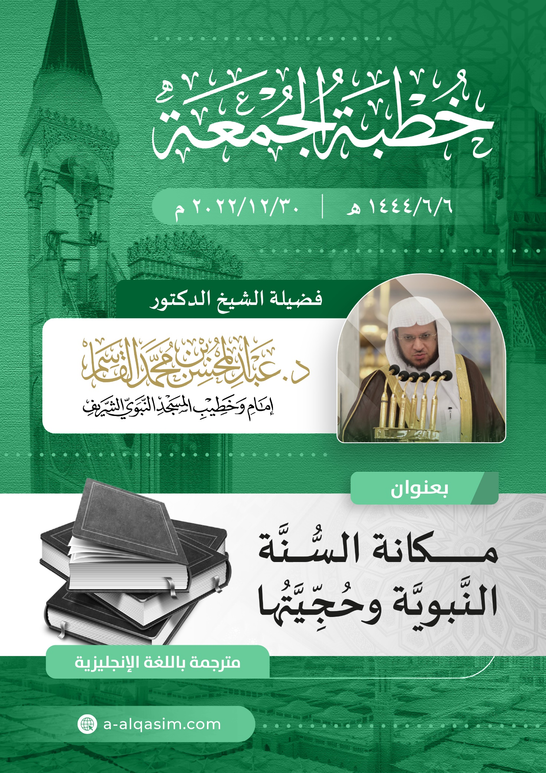

1. This sermon was delivered on Friday the 6th of Jumada-Al-Ula 1444AH, in Al-Masjid An-Nabawi.