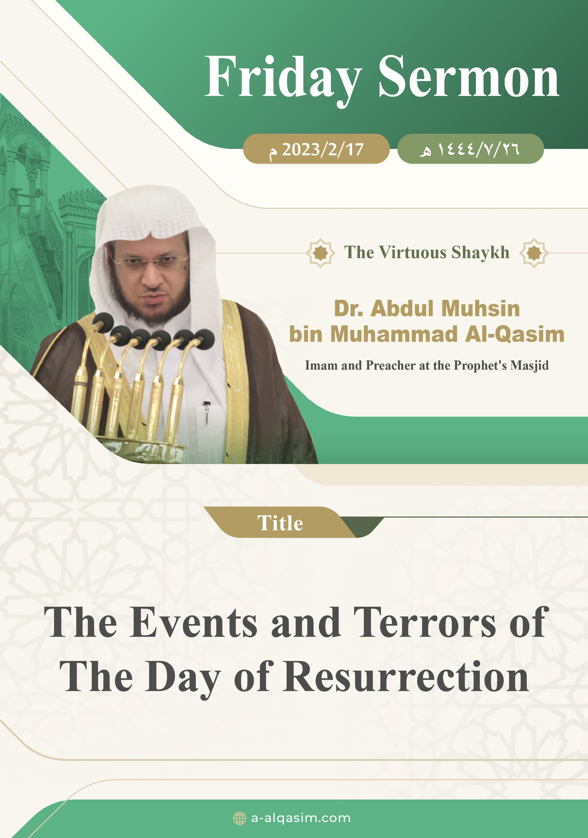

The Events and Terrors of The Day of Resurrection ⁽⁾
Verily, all praise is for Allah. We praise Him, seek His aid and His forgiveness. We seek refuge in Allah from the evil of our souls, and from our bad deeds. Whomsoever Allah guides none can misguide, and whomsoever Allah leaves to go astray none can guide. I testify that there is none worthy of worship except Allah, alone with no partners. And I testify that our Prophet Muhammad is His slave and messenger. May Allah's peace and blessings be upon him, as well as his family and companions in abundance.
Amma ba‘d (To proceed):
O slaves of Allah! Fear Allah as He deserves to be feared and be conscious of Him in secret and in open.
Ayyuhal-Muslimun (O Muslims!)
Allah has established the religion of Islam on foundations which an individual’s Islam is not valid without the belief in them. From these pillars is:
Having certainty in the Last Day, and Allah has established in His book proofs that necessitate certainty in it. From them are: His ability to create from nothing; giving life to the dead in this world; and His ability to create animals and produce vegetation with water. All the Prophets mentioned the Last Day to their nations.
It was from the way of the Prophet (may Allah's peace and blessings be upon him) to regularly mention the Hereafter to his Companions, along with its details in his sermons; until it was as if they could see it with their own eyes. Ibn Al-Qayyim (may Allah have mercy on him) said, "The sermons of the Prophet (may Allah's peace and blessings be upon him) would revolve around praising Allah for His favours, as well as His perfect characteristics, and praiseworthy attributes and actions. [They would also be focused on] teaching the fundamentals of Islam; making mention of Paradise, the Hellfire and the Hereafter; enjoining the consciousness of Allah and clarifying that which angers and pleases Him."
It the right of Allah that nothing is raised [in its worth or usefulness] except that He [eventually] brings it back down. He created the universe in the best image, and facilitated it for the Creation, so that they can worship Him in this world. The Hour will not be established until Allah destroys the traces of this universe, and changes its order. The sun will be wrapped [in darkness] and its light will disappear. The moon will be dimmed and its beauty will dwindle and come to nothing. The planets will be detached from their orbits and become scattered, and the stars will disperse, and their light will vanish. The seas will erupt, and their water will be set ablaze. The mountains will be blown away. The Earth will be shaken violently, and their will be neither any elevations nor depressions [to be seen]. Rabb Al-Alamin (The Lord of the Worlds) will take hold of it with His hand, showing His Power and Magnificence. The sky will split open and change colour, and Ar-Rabb (the Lord) will fold it with His right hand.
{ﲵ ﲶ ﲷ ﲸ ﲹ ﲺ ﲻ ﲼ ﲽ ﲾ ﲿ ﳀ ﳁﳂ ﳃ ﳄ ﳅ ﳆ}
{They have not shown Allah His proper reverence — when on the Day of Judgment the [whole] earth will be in His Grip, and the heavens will be rolled up in His Right Hand. Glorified and Exalted is He above what they associate [with Him]!} [Az-Zumar: 67]
Allah (may He be exalted) has named the Day of Resurrection with many names, such that the People would reflect over its mention and ponder over it. From its names are: Yawm Ad-Din (The Day of Recompense), Yawm Al-Fasl (The Day of Judgement), Yawm Al-Hisaab (The Day of Accounting), Yawm Al-Hasrah (The Day of Regret), and Yawm Al-Jam‘ Wal-Ba‘th (The Day of Gathering and Resurrection). When Allah gives permission for the Hour to be established, He will command Israfil to blow into the Horn; causing the slaves' souls to fly and return back to their bodies.
{ﲬ ﲭ ﲮ ﲯ ﲰ ﲱ ﲲ ﲳ ﲴ ﲵ}
{The Trumpet will be blown [a second time], then—behold!—they will rush from the graves to their Lord.} [Yasin: 51]
The bodies of the created beings will grow after their decomposition just as vegetation grows. The Prophet (may Allah's peace and blessings be upon him) said, "Allah will send water from the sky and then the dead bodies will grow like vegetation grows. There is nothing of the human body that does not decay except one bone; that is the little bone at the end of the coccyx from which the human body will be recreated on the Day of Resurrection." (Agreed upon).
Thus, Allah will return the slaves' bodies, hairs, and skins to how they were in this world.
{ﱟ ﱠ ﱡ ﱢ ﱣﱤ ﱥ ﱦﱧ ﱨ ﱩ ﱪ}
{Just as We produced the first creation, [so] shall We reproduce it. That is a promise binding on Us. We truly uphold [Our promises]!} [Al-Anbiya: 104]
The people will stand from their graves frightened. The first person to be resurrection from his grave will be our Prophet (may Allah's peace and blessings be upon him). The Prophet (may Allah's peace and blessings be upon him) said, "I am the leader of Adam's children on the Day of Resurrection, and the first to have his grave split open." (Narrated by Muslim). On that day, people will be barefoot and naked, "and the first to be clothed on the Day of Resurrection will be Ibrahim (peace be upon him)." (Agreed upon).
All the Creation – Jinn, Mankind, and animals – will be gathered together on a land in a description that is not known or familiar.
{ﲑ ﲒ ﲓ ﲔ ﲕ ﲖﲗ}
{On the Day when the earth will be changed into a different earth and the heavens as well} [Ibrahim: 48]
Rather [it will be] on a plain that is white in colour, with a hint of red. There will no distinguishing characteristics for anyone, and its Lord will stretch it like leather.

Whoever's life in this world was concluded in a good or bad action will be resurrected upon a similar manner on the Day of Judgement. The Prophet (may Allah's peace and blessings be upon him) said, "Every slave will be resurrected in the manner that he died." (Narrated by Muslim). Therefore, amongst the people there will be those who are gathered upon the action he would do in this world, from those whose punishment or reward has been hastened.
There will be groups of the believers whom Allah will shade on a day in which there is no shade except for His shade.
The people of disbelief will be humiliated and lowly, frightened and fearful.
{ﱓ ﱔ ﱕ ﱖ ﱗ ﱘ ﱙ ﱚ ﱛ *
ﱝ ﱞ ﱟ ﱠﱡ}
{The Day they will come forth from the graves swiftly, as if racing to an idol. Their eyes lowered in fear and humility, utterly covered with disgrace.} [Al-Ma‘arij: 43-44]
The Day of Resurrection is a day that eyes of the Creation will stare in horror, and the hearts will reach the throats.
{ﲨ ﲩ ﲪ * ﲬ ﲭ}
{Hearts on that Day will tremble. Their eyes will be downcast.} [An-Naziat: 8-9]
The Sun will be brought close to them, to the point that its heat harms them. They will sweat according to their actions, causing their difficulty to increase. The Prophet (may Allah's peace and blessings be upon him) said, "The people will sweat so profusely on the Day of Resurrection that their sweat will sink seventy cubits deep into the earth, and it will rise up till it reaches the people's mouths and ears." (Agreed upon). And he said, "The people will suffer such distress and agony that they will not be able to bear, and they will not be able to stand it." (Agreed upon).
When the standing becomes long and drawn out for the Creation, and they are unable to bear its length; they will search for someone to intercede for them near their Lord, such that He comes and judges between them. The Prophet (may Allah's peace and blessings be upon him) said, "The people will say to each other, 'Do you not see the state you are in and the condition you have reached? Why do you not look for someone who can intercede for you with your Lord?'" (Agreed upon). Thus, they will come to Adam and ask him to intercede to his lord, but he will excuse himself and say, "Verily, My Lord is angry today in a way in which He has never been angry before and will never be angry again." Thereafter, they will approach Nuh, Ibrahim, Musa and Isa. All of them will excuse themselves, and say something similar to what Adam (peace be upon him) said. Then, they will come to our Prophet Muhammad (may Allah's peace and blessings be upon him), [asking him to intercede], and he will say, "I am deserving of doing so." The Prophet (may Allah's peace and blessings be upon him) said, "I will go and prostrate to my Lord beneath the Throne. Then I will be given words of praise such have never been given to anyone before me, then it will be said, 'O Muhammad! Raise your head; ask, for it will be given to you, and intercede, for your intercession will be accepted.' I will raise my head and say, 'My ummah, O Lord! My nation, My nation!'." (Agreed upon).
Then Rabb Al-Alamin (The Lord of the Worlds) will come in His glory and magnificence, and will begin judging between His slaves. The whole Creation will be presented to him in a single row.
{ﱜ ﱝ ﱞ ﱟ}
{They will be presented before your Lord in rows} [Al-Kahf: 48]
Their Lord will speak to them, clarify to them their actions and that which their hands earned and He will affirm to them that which they did. The Messengers will be brought as witnesses over their nations, and the Angels will stand as witnesses. The Earth will testify to what was done upon it, and the limbs will utter what they were used for.
The scrolls that were in the hands of the Recording Angels that write the servants’ statements and actions will be distributed. So on that day, that which was hidden will become apparent.
{ﲁ ﲂ ﲃ ﲄ ﲅ ﲆ}
{That Day, you will be exhibited [for judgement], and none of your secrets will stay hidden.} [Al-Haqqah: 18]
That which the slave did and forgot about was not forgotten or neglected by Allah. Rather, He kept account of all of that, and He will present it to the slave [on that day], and he will not deny any of it.
{ﳄ ﳅ ﳆﳇ ﳈ ﳉ ﳊ ﳋ ﳌ}
{Allah has kept account of it all, while they have forgotten it. And Allah is a Witness over all things.} [Al-Mujadilah: 6]
Allah (may He be glorified) is the most swift in reckoning. He will reckon the whole of Creation at one time by His will and power. The first thing which the slave will be reckoned for is the oneness of Allah, and following His Messengers. Then it will be the Salah (Prayer), if it is upright then the rest of his actions will be upright; and if it is impaired, then the slave has become destroyed and lost. The feet of a slave will not move from that position until he is asked about four things: "About his life and how he spent it, his knowledge and what he did with it, his wealth and from where he earned it and where he spent it, and his body and how he used it." (Narrated by At-Tirmidhi).
{ﲱ ﲲ ﲳ ﲴ ﲵ}
{Then, on that Day, you will definitely be questioned about [your worldly] pleasures.} [At-Takathur: 8]
The people, when taken to account, will either be joyful, who take their book with his right hand; and his Lord gives him an easy reckoning, and so he returns back happily to his family and companions on the plain.
{ﱱ ﱲ ﱳ ﱴ ﱵ * ﱷ ﱸ ﱹ ﱺ *
ﱼ ﱽ ﱾ ﱿ}
{As for he who is given their record in their right hand, he will have an easy reckoning, and will return to his people joyfully.} [Al-Inshiqaq: 7-9]
Or he will be a wretched person, who is given his book in his left hand, or behind his back; causing him to become frightened, and say:
{ﲳ ﲴ ﲵ ﲶ}
{"I wish I had not been given my record."} [Al-Haqqah: 25]
{ﲁ ﲂ ﲃ ﲄ ﲅ ﲆ * ﲈ ﲉ ﲊ * ﲌ ﲍ}
{As for he who is given his record from behind his back, he will cry out for destruction, and will burn in the blazing Fire.} [Al-Inshiqaq: 10-12]
His Lord will reckon him in a difficult way, hold the smallest of his actions against him, and punish him for every major and minor sin.
In that great setting, Allah's justice and all-encompassing knowledge will become apparent to the Creation. The believers will witness His abundant mercy, as well as His bounty, generosity and kindness. He will deal with the good-doer with His excellence, and bestow favour upon the repentant with His forgiveness. The Prophet (may Allah's peace and blessings be upon him) said, "Allah will bring the believer close and will shelter him with His screen, then He will say, ‘Do you remember such and such a sin? Do you remember such and such a sin?’ and he will say, 'Yes, O Lord,' until He makes him confess his sins and he thinks that he is doomed. Then Allah will say, 'I concealed it for you in the world and I forgive you for it today.’ Then he will be given the book of his good deeds. But as for the disbeliever and the hypocrite, then the witnesses will say:
{ﳂ ﳃ ﳄ ﳅ ﳆﳇ ﳈ ﳉ ﳊ ﳋ ﳌ}
{‘These are the ones who lied against their Lord!’ No doubt! the curse of Allah is upon the wrongdoers} [Hud: 18].” (Agreed upon).
The scales will be raised so that the actions of the Creation can be weighed in them. The proof will be established against the Creation, and Allah's justice will be apparent in them.
{ﱚ ﱛ ﱜ ﱝ ﱞ ﱟ ﱠ ﱡ ﱢﱣ
ﱤ ﱥ ﱦ ﱧ ﱨ ﱩ ﱪ ﱫﱬ ﱭ ﱮ ﱯ}
{We will set up the scales of justice on the Day of Judgment, so no soul will be wronged in the least. And [even] if a deed is the weight of a mustard seed, We will bring it forth. And sufficient are We as a Reckoner.} [Al-Anbiya: 47]
Whoever's scales are heavy [with good deeds] will be successful and saved, and whoever's scales are light [in good deeds] will be destroyed. The Creation will vary in weight according to their actions and the soundness of their hearts. The Messenger of Allah (may Allah's peace and blessings be upon him) said, "A huge fat man will be brought on the Day of Resurrection, and he will not weigh more before Allah than the wing of a mosquito." (Agreed upon).
From His justice (may He be glorified) in the Hereafter is that the Creation will seek retribution from each other. He who wronged another will repay his wrongdoing on the plains of the Day of Resurrection. The Prophet (may Allah's peace and blessings be upon him) said, "All rights will be settled on the Day of Resurrection; even the hornless sheep will settle its scores with the horned sheep." (Narrated by Muslim). The true loser is he whose good deeds are taken away to be given to someone else when is in need of them most. The Prophet (may Allah's peace and blessings be upon him) said, "Whoever has wronged his brother with regard to his honour or anything else, let him seek his pardon today, before there will be no dinar or dirham (i.e. on the Day of Resurrection), when if he has any good deeds, they will be taken in proportion to his wrongdoing, and if he has no good deeds, then some of the bad deeds of the one whom he wronged will be taken and added to his burden." (Narrated by Al-Bukhari).
On the plains of the Day of Resurrection, Allah will honour our Prophet (may Allah's peace and blessings be upon him) with a huge cistern. Two spouts will pour water into it from the river of Al-Kawthar in Paradise. Its length and width are equal to a month. Its water is whiter than milk and sweeter and honey. Its fragrance is better than misk (a type of perfume). There will be jugs inside it, that are as many as the stars in number. Whoever drinks from it will never become thirsty again. And there will be some people that are prevented from it because they introduced into Allah's religion that which he did not permit.
When Allah completes judging between the slaves, they will go off to either Paradise or Hell. The believers will be given their light ahead of them and on their right according to their level of faith. The Bridge will be placed over Hell, and it will be extremely slippery and the feet will not stand firm on it. The people will cross it according to their actions. The believers will cross it [at different levels, some] like the blink of an eye, others like lightning, others like the wind, others like bird and others like the finest horses. It will have hooks and thorns that will grab the people. There will be those that are saved, and those that are scratched, and those that are pushed into the fire of Jahannam. All the while, our Prophet (may Allah's peace and blessings be upon him) will be upon the Bridge, saying: "O Lord! Save them! Save them!"
When the believers cross the Bridge, they will be saved from the Fire. However they will be accounted for at a bridge between Paradise and Hell. Any disputes they had between each other in the worldly life will be settled there. When they are purified and cleansed, they will be given permission to enter Paradise. However they will not enter it until our Prophet (may Allah's peace and blessings be upon him) will come and Paradise will be opened for him, and he will be the first to enter it; and then his nation will enter. Thereafter, the other nations will enter. The Prophet (may Allah's peace and blessings be upon him) said, "I will approach Paradise's door on the Day of Resurrection, and ask for it to be opened. The gatekeeper will say, 'Who are you?' I will answer, 'Muhammad.' He will say, 'I was commanded to open the door for you, and not for anyone before you'." (Narrated by Muslim).
Wa ba‘d Ayyuhal-Muslimun (To conclude, O Muslims!)
The Hour is approaching, and there is no doubt concerning it. The Day of Resurrection is a difficult, heavy, long day; consisting of many difficulties. The heads of young boys will turn white from its terrors. And Allah commanded the Prophet (may Allah's peace and blessings be upon him) on more than one occasion to warn his nation of that day. He said:
{ﱁ ﱂ ﱃ ﱄ ﱅ ﱆ ﱇ ﱈ ﱉ ﱊ ﱋ ﱌ}
{And warn them [O Prophet] of the Day of Regret, when the matter will be concluded, and [yet] they are [in a state of] heedlessness and they do not believe.} [Maryam: 39].
{ﱑ ﱒ ﱓ ﱔ ﱕ ﱖ ﱗ ﱘﱙ
ﱚ ﱛ ﱜ ﱝ ﱞ ﱟ ﱠ}
{Warn them [O Prophet] of the approaching Day when the hearts will jump into the throats, filled [with distress]. The wrongdoers will have neither a close friend nor intercessor [who is] obeyed.} [Al-Ghafir: 18].
The smart person is the one who prepares for that day, and its difficulties and terrors; and turns back to Allah and repents.
A‘udhu billahi min ash-shaytanir-rajim (I seek refuge in Allah from the accursed Shaytan).
{ﱍ ﱎ ﱏ ﱐ ﱑ ﱒ ﱓ ﱔ ﱕ ﱖﱗ
ﱘ ﱙﱚ ﱛ ﱜ ﱝ ﱞ ﱟ}
{O believers! Be mindful of Allah and let every soul look to what [deeds] it has sent forth for tomorrow [i.e. the Hereafter]. And fear Allah, [for] certainly Allah is All-Aware of what you do.} [Al-Hashr: 18]
May Allah bless me and you by The Great Quran.

The Second Sermon
All praise is for Allah for His excellence and kindness, and gratitude is due to Him for His guidance and favours. I testify that there is none worthy of worship except Allah alone having no partners; glorifying Him, and I testify that Muhammad is His slave and messenger, may Allah's peace and blessings be upon him, and his family and companions in abundance.
Ayyuhal-Muslimun (O Muslims!)
Knowledge of the Last Day is obligatory upon every Muslim. Whoever increases in knowledge regarding it, also increases in his faith. The Creation is in need of remembering it at all times, and hastening towards the actions it necessitates. It is a duty upon the slave to learn about that day that which rectifies his belief, and aids him to adhere to uprightness in his statements and deeds. The successful person is the one to whom Allah grants success, and the failed person is the one who Allah entrusts to himself.
Thereafter, know that Allah has commanded you to invoke His peace and blessings upon His Prophet…

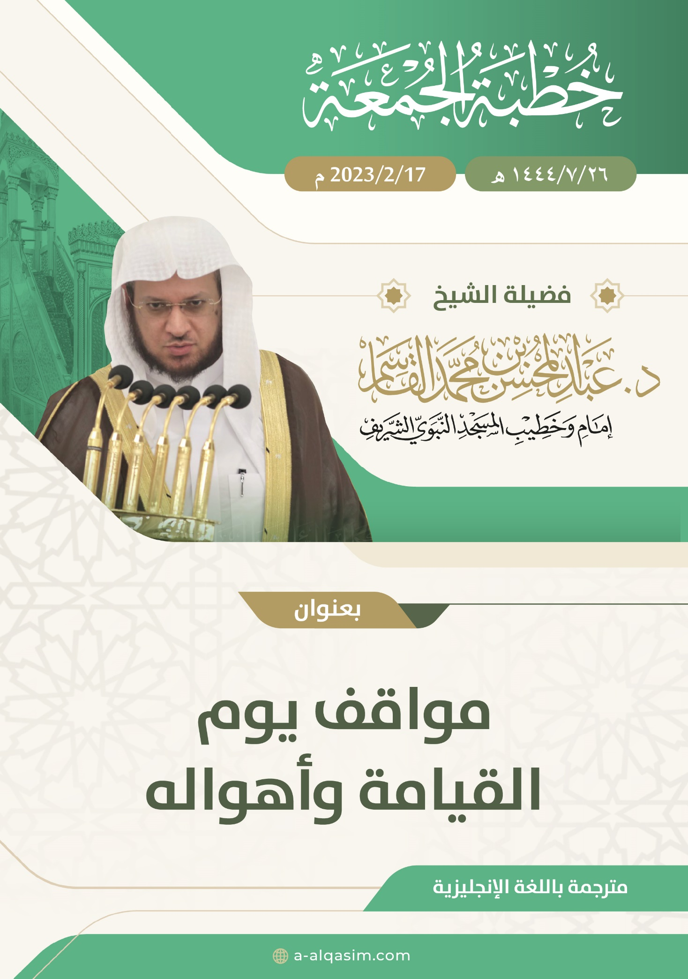

() This khutbah was delivered on Friday the 26th of Rajab 1444AH, in Al-Masjid An-Nabawi.

