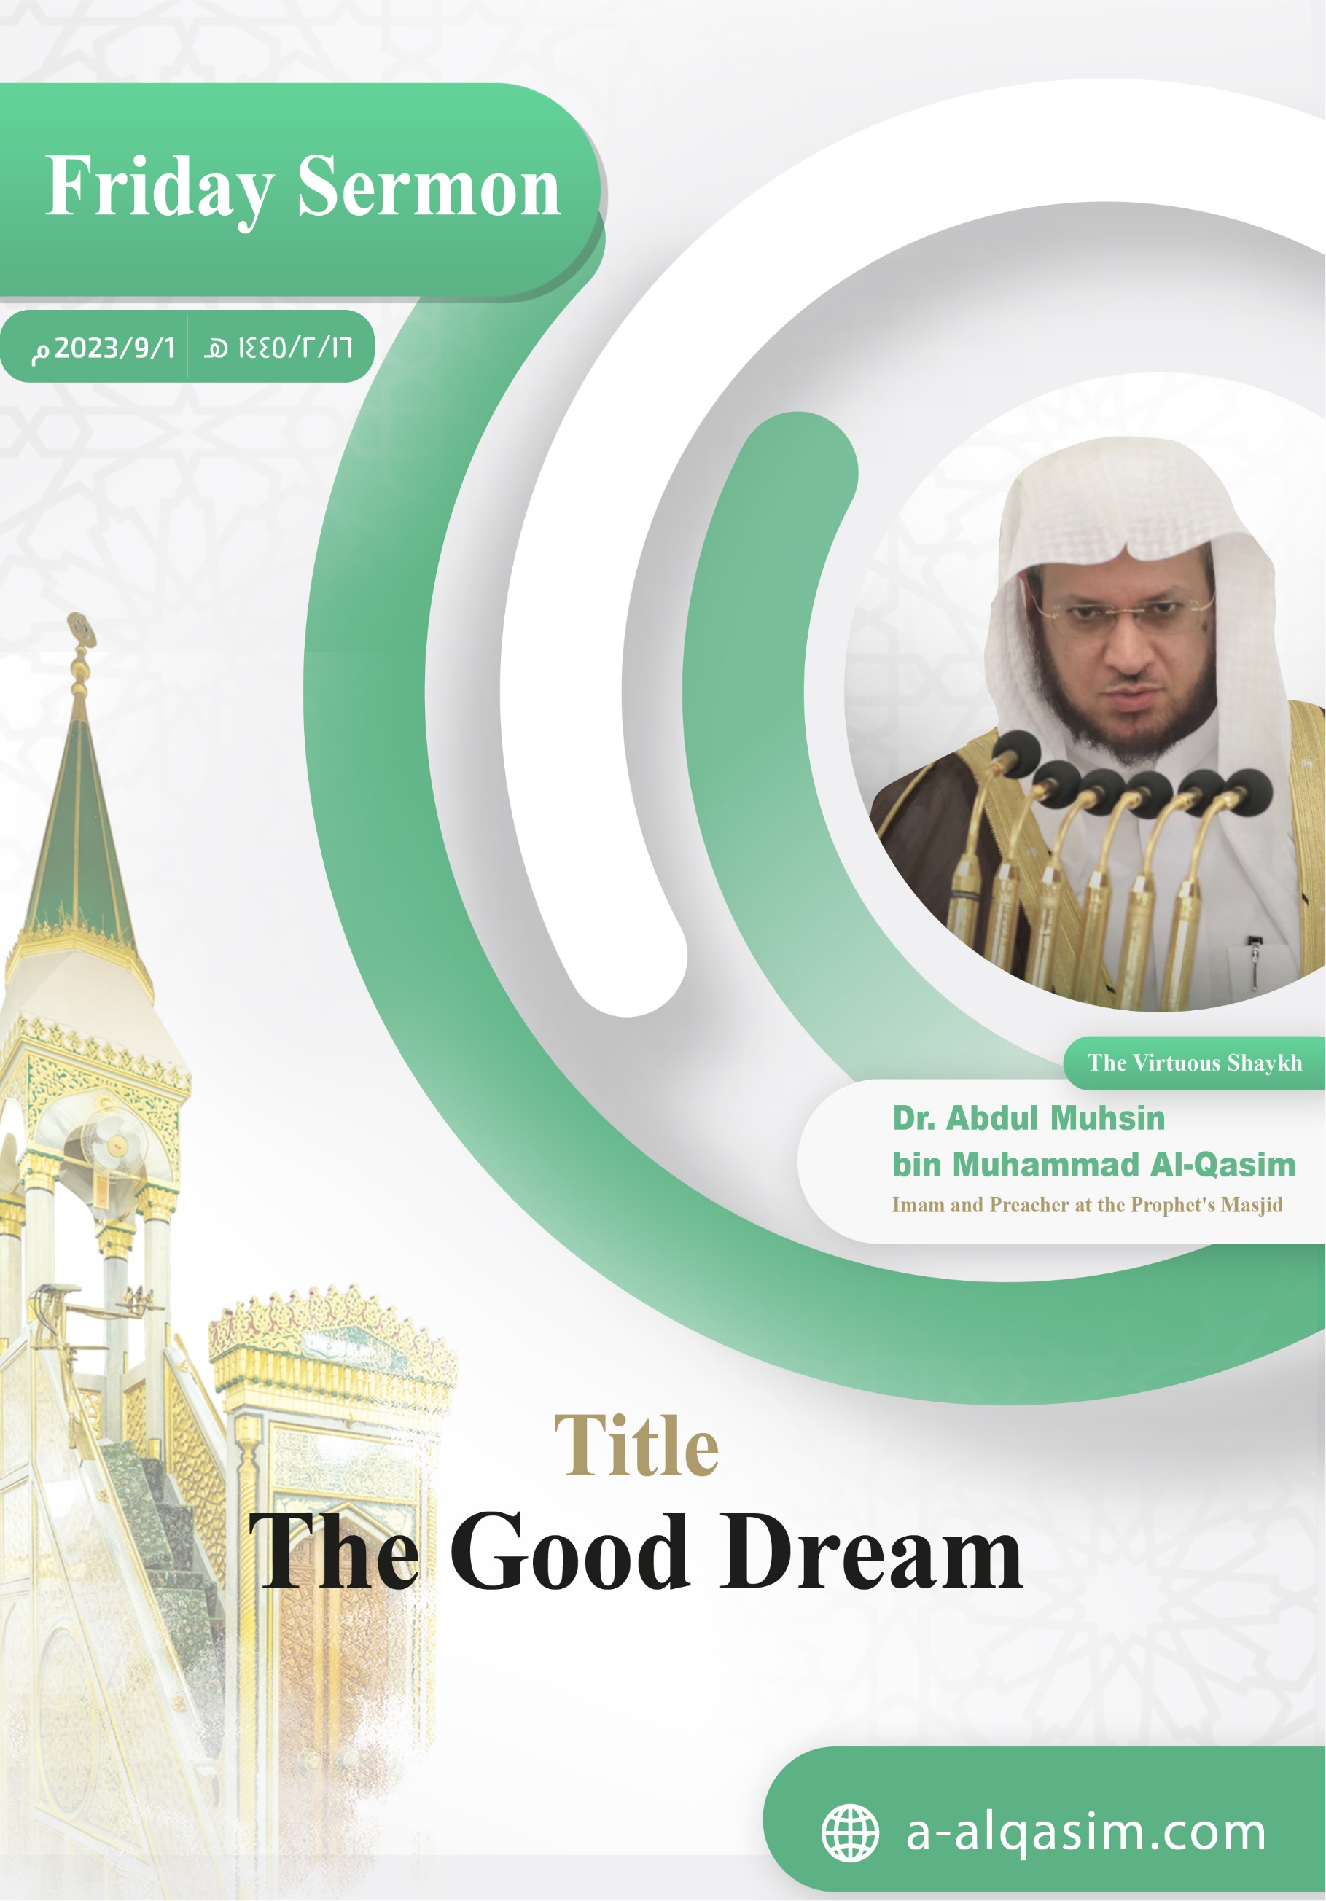

The Good Dream []
Verily, all praise is for Allah. We praise Him, and seek His aid and forgiveness. We seek refuge in Allah from the evil of our souls, and from our bad deeds. Whomsoever Allah guides none can misguide, and whomsoever Allah leaves to go astray none can guide. I testify that there is none worthy of worship except Allah, alone with no partners. And I testify that our Prophet Muhammad is His slave and messenger. May Allah's peace and blessings be upon him, as well as his family and companions in abundance.
Amma ba‘d:[]
O Slaves of Allah! Fear Allah as He deserves to be feared, and be conscious of Him in secret and in open.
Ayyuhal-Muslimun:[]
Allah has amply bestowed His favours upon His slaves – both the apparent and hidden ones – in their wakeful state and their sleep. He manages and regulates every affair by night and by day. And He has withheld – by His wisdom – the knowledge of the unseen from the creation, and there is no way to know the unseen except that which Allah informed His messengers of. Allah (may He be exalted) said:
{ﳄ ﳅ ﳆ ﳇ ﳈ ﳉ ﳊ *
ﳌ ﳍ ﳎ ﳏ ﳐ ﳑ ﳒ ﳓ ﳔ ﳕ ﳖ ﳗ ﳘ}
{˹He is the˺ Knower of the unseen, disclosing none of it to anyone, except messengers of His choice. Then He appoints angel-guards before and behind them.} [Al-Jinn: 26-27]
From Allah's hidden blessings and the amazing wonders of His creation is that He preserved a part of prophethood, through which He informs those He wishes of His slaves knowledge of something from the unseen in their sleep. The Prophet (may Allah's peace and blessings be upon him) said: "Nothing remains of the prophethood except for al-mubashirat. They said: What is al-mubashirat? He said: The good dream." (Narrated by Al-Bukhari). They contain from Allah's beautiful knowledge and kindness that which increases the believer in his faith. They inform him regarding the past, present, and future that which suffices him from the lies of the soothsayer. They contain an encouragement towards good, a caution against evil, as well as glad tidings and warnings.
Dreams have a lofty position in the Islamic legislation. They accompanied the prophets in the most difficult trials and events. They are a form of revelation for them, but not for others. Ibrahim said to Ismail (peace be upon them both):
{ﳍ ﳎ ﳏ ﳐ ﳑ ﳒ ﳓ}
{O my dear son! I have seen in a dream that I was sacrificing you.} [As-Saffat: 102]
Thus, Allah raised the rank of Ibrahim because of his fulfilment of the dream and obedience to His Lord's command. He kept for him a truthful praise generation after generation. Allah (may He be exalted) said:
{ﱝ ﱞ ﱟ ﱠ * ﱢ ﱣ ﱤ * ﱦ ﱧ ﱨ}
{And We left for him [an honourable mention goodly remembrance] among the later generations. “Peace be upon Abraham.” This is how We reward the good-doers.} [As-Saffat: 108-110]
The life of Yusuf (peace be upon him) started with a dream:
{ﲵ ﲶ ﲷ ﲸ ﲹ ﲺ ﲻ ﲼ ﲽ ﲾ ﲿ}
{O my father, indeed I have seen [in a dream] eleven stars and the sun and the moon; I saw them prostrating to me.} [Yusuf: 4]
And this dream came true, whilst he was honoured and raised:
{ﱺ ﱻ ﱼ ﱽ ﱾ ﱿ ﲀﲁ }
{And he raised his parents upon the throne, and they bowed to him in prostration.} [Yusuf: 100]
And the beginning of this ummah's (nation's) good and light was through dreams. Aishah (may Allah be pleased with her) said: "The beginning of the revelation that came to the Messenger of Allah (may Allah's peace and blessings be upon him) was good dreams in [his] sleep. He never saw a dream except that it came true like bright daylight." (Agreed upon).
In the Battle of Badr, Allah showed His prophet victory in his dream. Thus, he informed his companions of this. Their hearts were strengthened by this, and they had the courage to go to war with their enemies despite their small number.
{ﲋ ﲌ ﲍ ﲎ ﲏ ﲐﲑ ﲒ ﲓ ﲔ ﲕ ﲖ ﲗ ﲘ ﲙ ﲚ ﲛﲜ }
{˹Remember, O Prophet,˺ when Allah showed them in your dream as few in number. Had He shown them to you as many, you ˹believers˺ would have certainly faltered and disputed in the matter. But Allah spared you ˹from that˺.} [Al-Anfal: 43]
And Allah showed His prophet the Conquest of Makkah whilst he was in Madinah; and thus it was a glad tiding for them:
{ﲠ ﲡ ﲢ ﲣ ﲤ ﲥﲦ ﲧ ﲨ ﲩ ﲪ ﲫ ﲬ ﲭ
ﲮ ﲯ ﲰ ﲱ ﲲﲳ}
{Indeed, Allah will fulfil His Messenger’s vision in all truth: Allah willing, you will surely enter the Sacred Mosque, in security—˹some with˺ heads shaved and ˹others with˺ hair shortened—without fear.} [Al-Fath: 27]
And Allah allowed him to conquer it after the passing of a year.
When the Prophet (may Allah's peace and blessings be upon him) saw a dream, he would relate it to his companions . In fact, after he prayed the Fajr prayer, he would face His companions and ask them: "Did any of you see a dream last night?" (Agreed upon).
The foundation of the adhan's legislation was affirmation from the Prophet (may Allah's peace and blessings be upon him) for the dream that the companion Abdullah ibn Zayd (may Allah be pleased with him) saw. He said: "When morning came, I went to the Messenger of Allah (may Allah's peace and blessings be upon him) and told him what I had seen. He said: 'Verily, this is a true dream, if Allah wills. Get up with Bilal and tell him what you have seen, and let him call out with it." (Narrated by Ahmad). Ibn Abd Al-Barr said: "The Imams of guidance from the Companions and the Followers and those that came after them from the scholars of the Muslims – Ahl As-Sunnah Wa Al-Jama'ah (The People of the Sunnah and the community) – have unanimously agreed upon believing in it."
Dreams are of three types: one of them is true and will certainly occur, and the other two being either from the Shaytan or a mixture of false dreams. The Prophet (may Allah's peace and blessings be upon him) said: "Dreams are of three types: a good dream which is glad tidings from Allah, a dream from the Shaytan which causes distress, and a dream that comes from what a man is thinking of to himself." (Narrated by Muslim).
The good dream pleases the believer, but it does not deceive him. It is a portion of the prophethood. The Prophet (may Allah's peace and blessings be upon him) said: "The dreams of the believer are one of the forty-six parts of prophethood." (Agreed upon). It is from the glad tidings that remained after prophethood. The Prophet (may Allah's peace and blessings be upon him) was asked about the statement of Allah (may He be exalted):
{ﱑ ﱒ ﱓ ﱔ ﱕ ﱖ ﱗﱘ}
{For them are glad tidings in this worldly life and the Hereafter.} [Yunus: 64]
He replied: "It is the good dream that a Muslim sees or that is seen for him." (Narrated by Ahmad).
The true dream is a portion of prophethood, and prophethood is divine revelation. The one who lies regarding [what he has seen] in his sleep has lied upon Allah, by claiming that Allah has shown him what he did not see. The Prophet (may Allah's peace and blessings be upon him) said: "Verily, from the worst of lies is for a person claiming to have seen a dream which he has not seen." (Agreed upon). On the Day of Resurrection, he will be commanded with that he has no ability to perform; in order to intensity his punishment. The Prophet (may Allah's peace and blessings be upon him) said: "Whoever speaks of a dream that he did not actually see will be ordered [on the Day of Judgement] to tie two grains of barley together, and he will never be able to do so." (Narrated by Al-Bukhari).
Even though the true dreams are mostly for the upright people, they may also happen to other than them. Yusuf (peace be upon him) interpreted the dream of his two companions in the prison, and their dream actualised [in the way he interpreted it]. He also interpreted the dream of the disbelieving king – [in which he saw] seven cows – and it came true. Al-Bukhari said in his Sahih: "Chapter: The dreams of prisoners, the wicked and the polytheists". Ibn Hazm (may Allah have mercy on him) said: "The dream of the disbeliever may come true, but it is not considered a portion of prophethood; nor it is from the glad tidings. Rather, it is a warning and admonition for him and others."
The dream of the daytime is true like the dream of the night. The Prophet (may Allah's peace and blessings be upon him) entered upon Umm Haram bint Milhan (may Allah be pleased with her), and he slept in her home during the daytime. [In his sleep,] he saw a dream and narrated it to her. (Agreed upon).
Whoever sees a dream that he likes should praise Allah for it, rejoice, and inform those he loves about it. As for the envious and the plotter, he should not inform them of what he has seen. Yaqub (peace be upon him) said:
{ﱁ ﱂ ﱃ ﱄ ﱅ ﱆ ﱇ ﱈ ﱉ ﱊﱋ}
{He replied: "O my dear son! Do not relate your vision to your brothers, or they will devise a plot against you."} [Yusuf: 5]
It is recommended for whoever sees [a dream] he dislikes to seek refuge in Allah from its evil and the evil of the Shaytan. He should also spit on his left thrice, and turn over to his other side. He should not inform anyone of it, and he should stand and pray. An-Nawawi (may Allah have mercy on him) said: "If he does only some of these things, that will suffice in repelling its harm by the permission of Allah (may He be exalted); as the ahadith have explicitly mentioned."
Interpreting dreams is from the knowledge of the Prophets and the people of Iman. It is a rare [branch of] knowledge which combines between [a divine] gift and acquisition [of its matters]. It is a blessing which Allah grants to whoever He wills. Allah (may He be exalted) said about Yusuf (peace be upon him):
{ﲵ ﲶ ﲷ ﲸﲹ}
{That We might teach him the interpretation of dreams} [Yusuf: 21]
Interpreting dreams is a fatwa (legal ruling). It is not permissible for anyone to engage in it without knowledge. Yusuf (peace be upon him) said to the two young men [in the prison]:
{ ﲛ ﲜ ﲝ ﲞ ﲟ}
{The matter about which you inquired has been decided.} [Yusuf: 41][]
And the King said:
{ﳆ ﳇ ﳈ}
{Tell me the meaning of my dream} [Yusuf: 43]
And the young man said:
{ ﱚ ﱛ ﱜ ﱝ }
{Interpret for us ˹the dream of˺ seven [fat] cows… } [Yusuf: 46]
Dream interpretation is based upon analogy, likening one thing to another, and linking between tangible and intangible things. Ibn Al-Qayyim (may Allah be pleased with him) said: "The examples mentioned in the Quran are all fundamentals and principles for the knowledge of dream interpretation for the one who can deduce from them proficiently. Likewise, the one who understands the Quran is able to interpret dreams through it in the best way. The authentic fundamentals of dream interpretation are only taken from the lamp of the Quran."
Whoever wants his dream to be interpreted should not have it interpreted except by one who is knowledge in this field. Not everyone who becomes well-known for their knowledge or sits to teach the people is good at interpreting dreams. Nor is the one who suffices with the books of dream interpreting a [true] interpreter. For the meaning of dreams can differ according to the person, as well as the time and place. It was said to Malik (may Allah have mercy on him): "Can everyone interpret dreams?" He replied: "Is the prophethood to be played with?!"
Whoever Allah grants the ability to interpret dreams well should adhere to Allah's consciousness. He should be far from showing-off and loving to be well-known. He should ask his Lord for [His] and to keep him upright. He should beware of self-amazement, for indeed it takes away blessings [from a person]. He should thank Allah for this blessing. Yusuf (peace be upon him) said out of gratitude for Allah's blessings:
{ﲮ ﲯ ﲰ ﲱ ﲲ ﲳ ﲴ ﲵ ﲶﲷ}
{My Lord! You have surely granted me authority and taught me the interpretation of dreams} [Yusuf: 101]
The one who issues rulings, as well as the one who interprets dreams and the doctor come to know the secrets of people which no one else know. It is a duty upon them to hide that which should not be made apparent.
The true dream will inevitably take place, regardless of whether it is interpreted or not. Yaqub said to Yusuf (peace be upon them both):
{ﱃ ﱄ ﱅ}
{O my dear son! Do not relate your vision [to your brothers]} [Yusuf: 5]
Yaqub did not interpret the dream, yet it still took place. The interpreter only uncovers the reality of what the dream represents. He may be correct, and he might be mistaken. The Prophet (may Allah's peace and blessings be upon him) said to Abu Bakr (may Allah be pleased with him) after the latter had interpreted a dream: "You are partly right, and partly wrong." (Agreed upon).
As for the time when it takes place, then it could be in the present; or it could take place in the near or far future. Abdullah ibn Shaddad (may Allah have mercy on him) said: "Yusuf's dream took place after forty years. This is the longest it can take to occur." The Muslim should know that whatever Allah decrees for him is good, regardless of whether it is in the present or the future.
Wa Ba‘d[], Ayyuhal-Muslimun:
When a long time had passed since the prophethood and its traces, Allah compensated the believers with dreams. The Prophet (may Allah's peace and blessings be upon him) said: "When the end of time draws near, the believer's dream will hardly be false." (Agreed upon). As for the time in which the light of prophethood is strong, then the appearance and strength of its light contains that which suffices from dreams.
The people with the most truthful dreams are those who are most truthful in speech in their wakeful state. The Prophet (may Allah's peace and blessings be upon him) said: "The most truthful of you in dreams is the most truthful of you in speech." (Narrated by Muslim). Ibn Hajar (may Allah have mercy on him) said: "Whoever is mostly truthful whilst awake, his truthfulness will extend to his sleep. Thus, he does not see except that which is true. This is in opposition to the liar, and the one who mixes between truth and falsehood; for verily his heart become dark and corrupt, and therefore he only sees mixed dreams which are false."
Therefore, adhere to truthfulness in speech and strongly hold on to the consciousness of Allah; and you will earn the good of this world and the Hereafter.
A‘udhu billahi min ash-shaytanir-rajim. []
{ﱺ ﱻ ﱼ ﱽ ﱾ ﱿ ﲀﲁ ﲂ ﲃ ﲄ ﲅ ﲆ ﲇ ﲈ ﲉ ﲊ ﲋ ﲌﲍ}
{And he raised his parents upon the throne, and they bowed to him in prostration. And he said: "O my father, this is the explanation of my dream of before. My Lord has made it come true.} [Yusuf: 100]
May Allah bless me and you by The Great Quran.

The Second Sermon
All praise is to Allah for His excellence and kindness, and gratitude is due to Him for His guidance and favours. I testify that there is none worthy of worship except Allah alone having no partners, glorifying Him; and I testify that Muhammad is His slave and messenger, may Allah's peace and blessings be upon him, as well as his family and companions in abundance.
Ayyuhal-Muslimun:
The religion was complete with the death of the Prophet (may Allah's peace and blessings be upon him). Rulings cannot be affirmed through dreams at all. Ash-Shatibi (may Allah have mercy on him) said: "The only benefit of dreams is that they are a glad tiding or a warning. However, rulings are not extracted from them."
Allah protected our prophet Muhammad (may Allah's peace and blessings be upon him) from the Shaytan being able to take his form. Therefore, whoever sees him in his dream has seen him in his true form. The Prophet (may Allah's peace and blessings be upon him) said: "Whoever sees me in a dream has indeed seen me, for the Shaytan cannot take my shape." (Agreed upon). If a person sees the Prophet (may Allah's peace and blessings be upon him) in his dream, this does indicate that he is better than others. Whoever sees him not in accordance with his attributes narrated in the Sunnah and the Seerah, or that he is commanding him with falsehood; this is only false mixed dreams. And all good lies in following the Prophet (may Allah's peace and blessings be upon him).
Thereafter, know that Allah has commanded you to invoke His peace and blessings upon His Prophet…

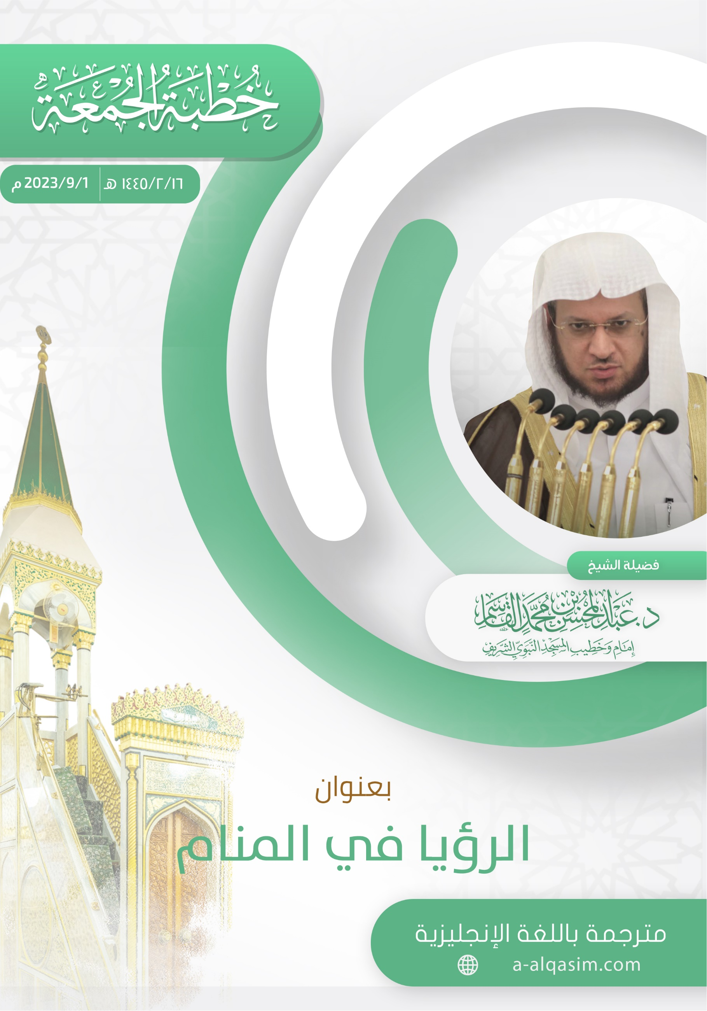

[] This khutbah was delivered in Al-Masjid An-Nabawi on Friday the 16th of Safar 1445 AH.
[] Translator's note: "Amma ba‘d": a phrase used to separate between the introduction and the topic of the sermon. It can be translated as: "to proceed".
[] Translator's note: "Ayyuhal-Muslimun" is an address meaning: "O Muslims".
[] Translator's note: The Arabic word in this verse – and the two to follow – come from the same root as the word "fatwa" (legal ruling). This indicates that interpreting dreams is indeed like issuing a legal ruling.
[] Translator's note: When coming at the end of a sermon, this phrase can be understood to mean: "To conclude".
[] Translator's note: This phrase means: "I seek refuge in Allah from the accursed Shaytan".]

