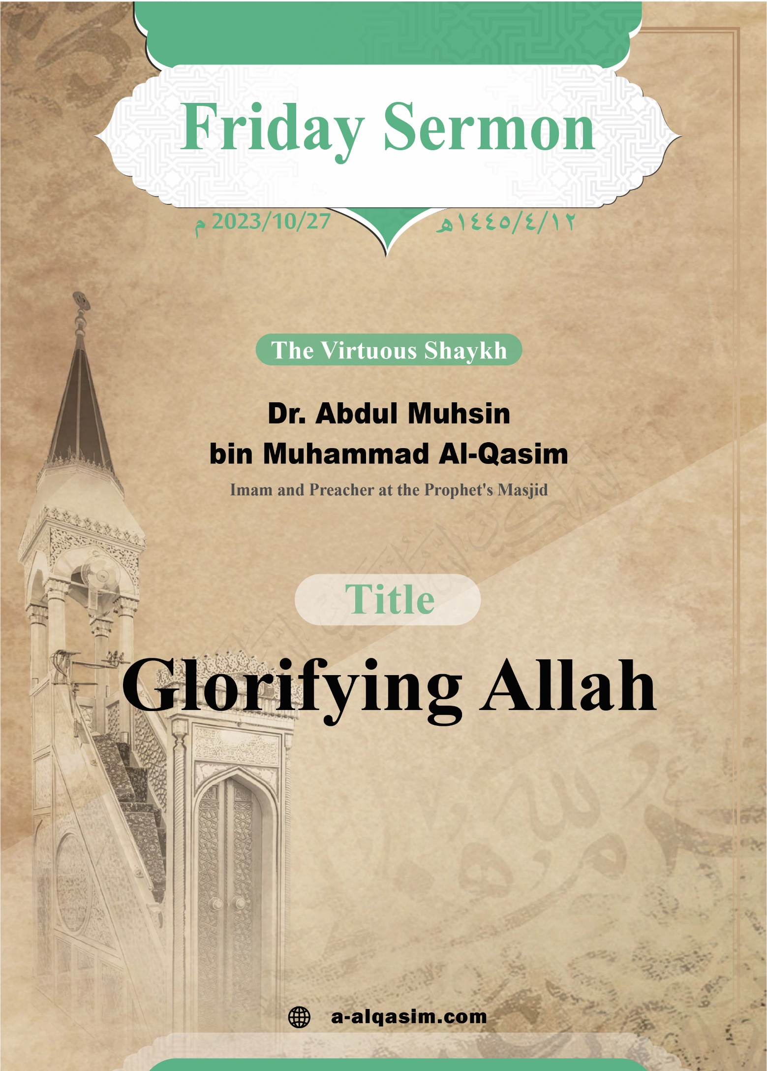

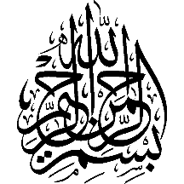
Glorifying Allah*
Verily, all praise is for Allah. We praise Him, and seek His aid and forgiveness. We seek refuge in Allah from the evil of our souls, and from our bad deeds. Whomsoever Allah guides none can misguide, and whomsoever Allah leaves to go astray none can guide.
I testify that there is none worthy of worship except Allah, alone with no partners. And
I testify that our Prophet Muhammad is His slave and messenger. May Allah's peace and blessings be upon him, as well as his family
and companions in abundance.
* This khutbah was delivered in
Al-Masjid An-Nabawi on Friday
the 12th of Rabi Al-Akhir
1445 AH.

Amma ba‘d:[]
O Slaves of Allah! Fear Allah as He deserves to be feared, and be conscious of Him in secret and in open.
Ayyuhal-Muslimun:[]
The reality of servitude to Allah arises from the highest level of love for Him combined with the utmost humility. Knowledge of the names and attributes of Allah (may He be exalted) is the foundation of knowledge and its most noble form. It is the knowledge upon which the unity of the Lord (may He be exalted) and His worship is based. The greatest need of souls is to know their Creator and Fashioner, and there is no way to achieve this except through knowledge of His attributes and names. The level of a slave’s servitude to his Lord, his intimacy with Him, his love for Him, and his reverence and glorification of Him will be in accordance with his level of knowledge of Allah’s names and attributes (may He be exalted).
And the more a slave increases in knowledge of Allah’s names and attributes, the more his faith increases and the stronger his certainty becomes. Allah makes the slave’s status in front of Him how the slave makes Allah’s status within himself.
All the names of the Lord (may He be exalted) are names of praise, and Allah described them all as being beautiful, because they indicate towards [His] attributes of perfection. One of His names is "Al-Kabier" (The Most Great), signifying His greatness in His essence, names, and attributes, and He is characterised by majesty and grandeur.
Whoever realises that Allah is over His creation, and greater than everything else magnifies Him immensely. Thus, he does not divert worship to anyone besides Him. Allah said:
{ﱜ ﱝ ﱞ ﱟ ﱠ ﱡ ﱢ ﱣ ﱤ ﱥ ﱦ ﱧ ﱨ ﱩ ﱪ ﱫ}
{That is because Allah [alone] is the Truth and what they invoke besides Him is falsehood, and [because] Allah [alone] is the Most High, the Most Great.} [Luqman: 30]
The creatures cannot be enumerated, nor does anyone understand their knowledge – the present and absent, nor does anyone encompass them except Allah – the Most Great. He said (may He be exalted):
{ﱻ ﱼ ﱽ ﱾ ﱿ}
{[He is the] Knower of the seen and the unseen—the Most Great, Most Exalted.} [Ar-Rad: 9]
Allah has the characteristic of speech and His speech is described with majesty and greatness. The Prophet (may Allah's peace and blessings be upon him) said: “When Allah decrees a matter in the heavens, the angels beat their wings in submission to His words, making a sound like a chain striking a rock. When the fear is banished from their hearts, they say: ‘What is it that your Lord has said?’ They say: ‘The truth, and He is the Most High, the Most Great.’” (Narrated by Al-Bukhari).
To our Lord belongs majesty and authority. He is the judge of His creation and He is just between them:
{ﲌ ﲍ ﲎ ﲏ}
{So the judgement is only with Allah, the Most High, the Most Great} [Ghafir: 12]
Allah commanded His slaves to glorify Him immensely, magnifying Him, and exalting Him from every shortcoming and deficiency that is attributed to Him. Allah (may He be exalted) said:
{ﲖ ﲗ ﲘ ﲙ ﲚ ﲛ ﲜ ﲝ ﲞ ﲟ ﲠ ﲡ ﲢ ﲣ ﲤ ﲥ ﲦ ﲧ ﲨﲩ
ﲪ ﲫ}
{And say, "Praise to Allah, who has not taken a son and has had no partner in [His] dominion and has no [need of a] protector out of weakness; and glorify Him immensely."} [Al-Isra: 111]
The objective of all the worship of the inhabitants of the heavens and the earth is to glorify, magnify and honour Allah. This is why the Takbir[] is a symbol of the great acts of worship. The Takbir in the prayer is humiliation in front of Allah’s greatness and grandeur. The number of Takbirs in a single day – from the adhan to the end of the prescribed words of remembrance in the five daily prayers and their regular voluntary prayers – is 375 Takbirs. Shaykh Al-Islam (may Allah have mercy on him) said, “In the statement: ‘Allah is the greatest’, there is an affirmation of Allah’s grandeur. This is because greatness includes grandeur, but it is more complete. ”
Hajj (pilgrimage) is one of the prominent symbols of religion, its slogan is monotheism and the glorification of Allah through saying Takbir Safa and Marwa, and during the stoning of the pillars.
The greatest days in the sight of Allah are the first ten days of Dhul-Hijjah. From the most beloved actions to Allah during them is saying Takbir. The Prophet (may Allah's peace and blessings be upon him) said: “There are no days that are greater before Allah or in which good deeds are more beloved to Him, than these ten days, so recite a great deal of Tahlil (saying ‘La Ilaha Illa Allah’ – ‘there is none worthy of worship except Allah’), Takbir and Tahmid (praising Allah by saying “Alhamdulillah”) during them.” (Narrated by Ahmad).
Saying Takbir is recommended in times of joy, such as during the two Eid celebrations, happy occasions, and hearing good news. The Prophet (may Allah's peace and blessings be upon him) said, “I hope that you will be half the people of Paradise.” Abu Sa'id Al-Khudri said, "So we said Takbir”. (Narrated by Al-Bukhari).
Allah is also glorified with Takbir upon seeing His signs, such as an eclipse, and at the time of amazement or any frightening matter. Some people asked the Prophet (may Allah's peace and blessings be upon him) to make a tree for them so that they could seek blessing from it, so he said, "Allahu Akbar! This is just like what the Children of Israel said:
{ﱏ ﱐ ﱑ ﱒ ﱓ ﱔﱕ}
{Make for us a god like their gods} [Al-Araf: 138] (Narrated by An-Nasa'i).
Starting a journey may be accompanied by worry, sadness, and fears. Magnifying Allah through Takbir is the traveller’s friend and the tranquillity of the desolate. The Prophet (may Allah's peace and blessings be upon him) used to say Takbir three times when he mounted his camel to embark on a journey. (Narrated by Muslim). Takbir is also recommended when witnessing something amazing in the creation of Allah, such as high places. Jabir (may Allah be pleased with him) said, "When we ascended, we would say Takbir." (Narrated by Al-Bukhari). Furthermore, when one reaches a higher ground, they should say Takbir.
A Muslim finishes his day with Takbir. When he goes to bed, he says “Subhan Allah” and “Alhamdulillah” 33 times, and he says “Allahu Akbar” 34 times.
Takbir is recommended in significant situations and in prominent places. Guidance is a great blessing that deserves gratitude. Part of being grateful for it is glorifying Allah for guidance to the landmarks of religion and what He loves and pleases. Allah (may He be exalted) said:
{ﲵ ﲶ ﲷ ﲸ ﲹ ﲺ ﲻ ﲼ ﲽ ﲾﲿ
ﳀ ﳁ ﳂ ﳃ ﳄ ﳅ ﳆ ﳇﳈ}
{Neither their meat nor blood reaches Allah. Rather, it is your piety that reaches Him. This is how He has subjected them to you so that you may proclaim the greatness of Allah for what He has guided you to.} [Al-Hajj: 37]
And part of being grateful for it is glorifying Allah takbir of Allah for steadfastness on guidance through performing worship. Allah (may He be exalted) said:
{ﲭ ﲮ ﲯ ﲰ ﲱ ﲲ ﲳ ﲴ ﲵ}
{So that you may complete the prescribed period and proclaim the greatness of Allah for guiding you, and perhaps you will be grateful.} [Al-Baqarah: 185]
Shaykh al-Islam (may Allah have mercy on him) said, "Takbir was prescribed for guidance, sustenance, and victory because these three are the greatest things sought by a slave, and they encompass all of their interests."
"Allahu Akbar" is a great phrase that Allah has commanded [to be proclaimed], for His greatness to prevail in the hearts. Allah says:
{ﲠ ﲡ }
{Glorify your Lord [alone].} [Al-Muddathir: 3]
Al-Qurtubi said, "It is said that the greatest phrase that the Arabs have to express greatness and majesty is 'Allahu Akbar.'" It is the word of Fitrah (innate nature) with which Allah created people. Anas ibn Malik (may Allah be pleased with him) reported, "The Messenger of Allah (peace be upon him) heard a man saying, 'Allahu Akbar, Allahu Akbar,' so he said, 'Upon the Fitrah.'" (Narrated by Muslim).
The reward for saying Takbir is great, and through it, one attains high ranks. It is one of the words that Allah loves. The Prophet (peace be upon him) said, "The most beloved words to Allah are: Subhan Allah, Alhamdulillah, La ilaha illa Allah, Allahu Akbar." (Narrated by Muslim). It is a charity upon the one that remembers Allah with it, and abundant good for him. He also said, "And every Takbir is charity." (Narrated by Muslim). The angels surround the gatherings of remembrance where Allah is glorified and magnified. (Agreed upon). The gates of heaven are opened through Takbir, Tahmid and Tasbih. Ibn Umar (may Allah be pleased with him) reported, "While we were praying with the Messenger of Allah (may Allah's peace and blessings be upon him), a man said, 'Allahu Akbar Kabiran, wa Alhamdulillah Kathiran, wa Subhan Allah Bukratan wa Asila (Allah is most Great, much praise be to Allah and glory be to Allah at the beginning and end of the day).' So the Messenger of Allah (peace be upon him) said, 'Who among you said such and such?' A man from the people said, 'It was me, O Messenger of Allah.' He (may Allah's peace and blessings be upon him) said, 'I was amazed by it. The gates of heaven were opened for it.'" (Narrated by Muslim). On the Day of Resurrection, it is heavy on the scales. The Prophet (may Allah's peace and blessings be upon him) said, "How very excellent are five things! How heavy they are in on the scale! [They are:] Laa ilaaha illa Allah, Allahu Akbar, Subhan Allah and Alhamdulillah, and the death of a righteous child whose parents seek reward for their loss, with Allah.” (Narrated by Ahmad).
Wa Ba‘d[], Ayyuhal-Muslimun:
Allah is Great, and there is none greater than Him. To Him belongs majesty in the heavens and the earth.. His greatness is a matter that the minds cannot comprehend, imagine, or understand the reality of. Whatever may occur to the minds of the people in terms of glorification, Allah is greater than it. “He will place the heavens on a finger, the earths on a finger, the trees on a finger, and the water and soil on a finger, and all other creations on a finger.” (Agreed upon). The believer seeks refuge in the great Lord, relies on Him, entrusts his affairs to Him, and calls upon Him alone and attaches himself to Him.
A‘udhu billahi min ash-shaytanir-rajim []
{ﲵ ﲶ ﲷ ﲸ ﲹ ﲺ ﲻ ﲼ ﲽ ﲾ ﲿ ﳀ ﳁﳂ ﳃ ﳄ ﳅ ﳆ}
{They have not shown Allah His proper reverence—when on the Day of Judgment the [whole] earth will be in His Grip, and the heavens will be rolled up in His Right Hand. Glorified and Exalted is He above what they associate [with Him]!} [Az-Zumar: 67]
May Allah bless me and you by The Great Quran.

The Second Sermon
All praise is to Allah for His excellence and kindness, and gratitude is due to Him for His guidance and favours. I testify that there is none worthy of worship except Allah alone having no partners, glorifying Him; and I testify that Muhammad is His slave and messenger, may Allah's peace and blessings be upon him, as well as his family and companions in abundance.
Ayyuhal-Muslimun:
There is no happiness, goodness, or bliss for the slaves except by knowing their Lord and Him alone being their ultimate goal. Recognising Him brings delight to their eyes. Pride is an exclusive characteristic of lordship. Allah has promised punishment for those who attribute themselves with it from among His creation. The Prophet (peace be upon him) said, "Honour is his lower garment, and pride is his upper garment, so whoever disputes with me, I will punish him." (Narrated by Muslim) Ibn al-Qayyim said, "As pride is greater and more encompassing, it was more deserving to be called the upper garment." Therefore, let the slave beware of tyranny on the earth, as well as arrogance, haughtiness and oppression towards creation. Whoever is given power and dominance, and is called upon by their own desire to oppress a weak person, whether it be a wife or someone else, should remember that Allah is greater than them in essence, power, and authority. Allah (may He be exalted) said:
{ﱡ ﱢ ﱣ ﱤ ﱥ ﱦﱧ ﱨ ﱩ ﱪ ﱫ ﱬ}
{But if they [change their ways] and obey you, do not be unjust to them. Surely Allah is Most High, Most Great.} [An-Nisa: 34]
Whoever has a strong knowledge that Allah is Great, his fear of Him increases, and his glorifies and loves Him, and performs his worship well. Arrogance, vanity, and showing off are expelled from his heart. Allah has made Paradise for His humble believing servants. He (may He be exalted) said:
{ﲷ ﲸ ﲹ ﲺ ﲻ ﲼ ﲽ ﲾ ﲿ ﳀ ﳁ ﳂﳃ
ﳄ ﳅ}
{That [eternal] Home in the Hereafter We reserve [only] for those who seek neither tyranny nor corruption on the earth. The ultimate outcome belongs [only] to the righteous.} [Al-Qasas: 83]
Thereafter, know that Allah has commanded you to invoke His peace and blessings upon His Prophet…

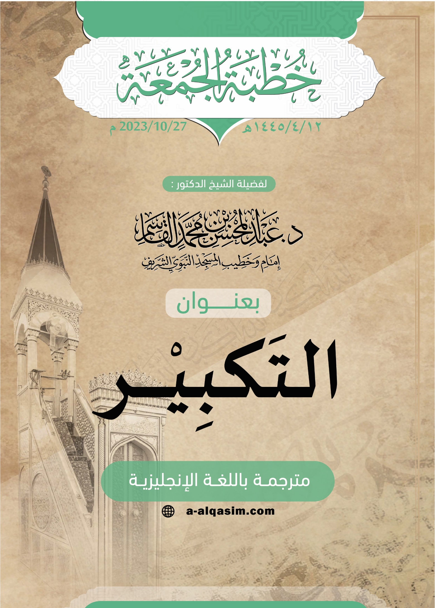

[] Translator's note: "Amma ba‘d": a phrase used to separate between the introduction and the topic of the sermon. It can be translated as: "to proceed".
[] Translator's note: "Ayyuhal-Muslimun" is an address meaning: "O Muslims".
[] Translator’s note: i.e.: the statement “Allahu Akbar”, meaning: “Allah is the greatest”.
[] Translator's note: When coming at the end of a sermon, this phrase can be understood to mean: "To conclude".
[] Translator's note: This phrase means: "I seek refuge in Allah from the accursed Shaytan".]

