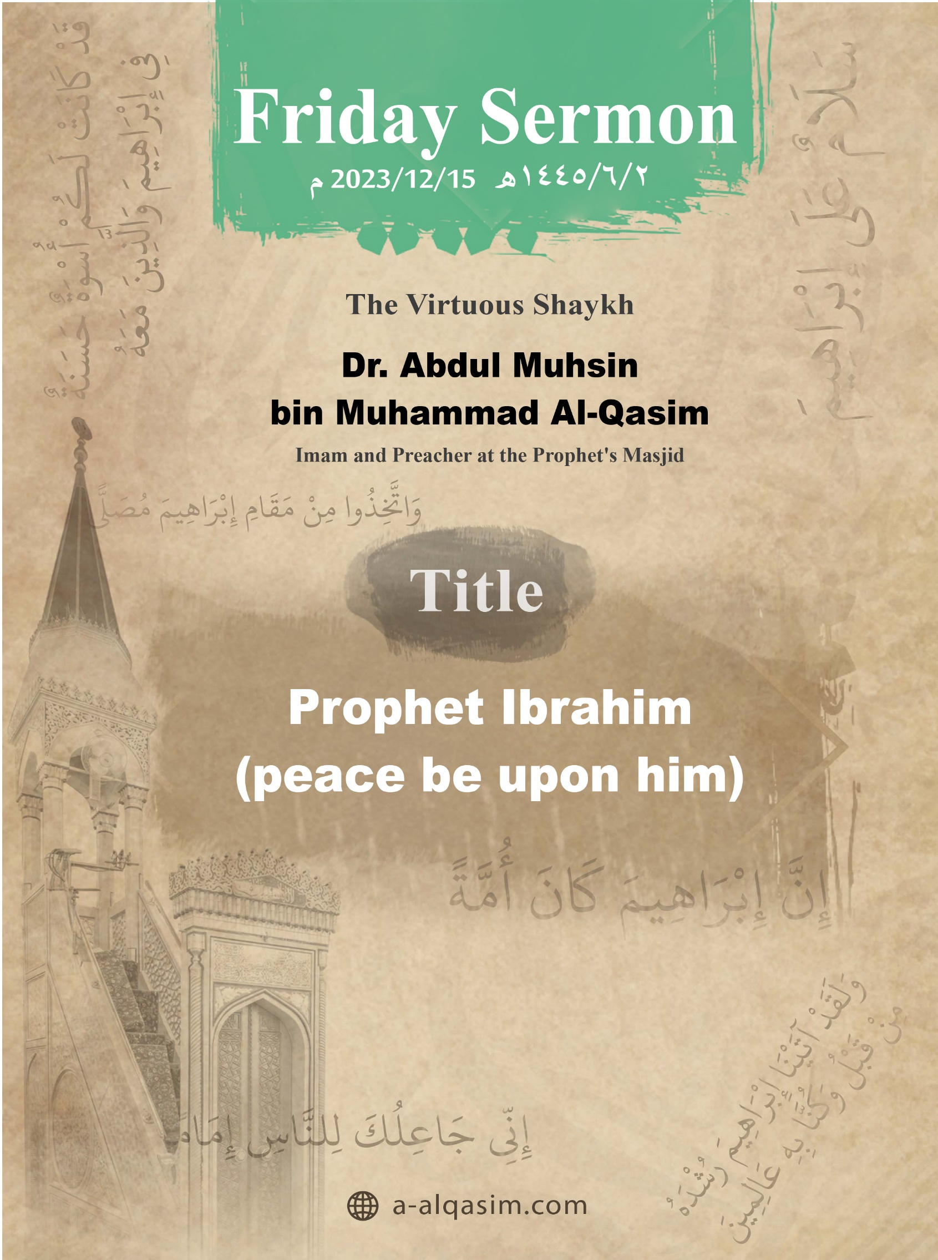

Prophet Ibrahim (peace be upon him)⁽⁾
Verily, all praise is for Allah. We praise Him, and seek His aid and forgiveness. We seek refuge in Allah from the evil of our souls, and from our bad deeds. Whomsoever Allah guides none can misguide, and whomsoever Allah leaves to go astray none can guide. I testify that there is none worthy of worship except Allah, alone with no partners. And I testify that our Prophet Muhammad is His slave and messenger. May Allah's peace and blessings be upon him, as well as his family and companions in abundance.
Amma ba‘d:[]
O Slaves of Allah! Fear Allah as He deserves to be feared, and be conscious of Him in secret and in open.
Ayyuhal-Muslimun:[]
Allah placed the creation as successors on earth and elevated some of them in rank over others. The highest rank – without exception – is the rank of the Messengers. They are the chosen ones from His slaves whom He sent peace upon among the creations. He distinguished them by entrusting them with His revelation, and He made them custodians of His message.
And Allah has made some of these great individuals (i.e. the Messengers) more virtuous than others. The best of them is our Prophet Muhammad (may Allah’s peace and blessings be upon him), followed by Ibrahim (peace be upon him). Allah has mentioned the stories of Ibrahim (peace be upon him) extensively in His book, from his upbringing to his ultimate destiny in the Hereafter. Allah chose him from among the creations. Allah (may He be exalted) said:
{ﲀ ﲁ ﲂ ﲃﲄ}
{Truly, We chose him in this world} [Al-Baqarah: 130]
In his youth, Allah bestowed upon him sound intellect and wise judgment. Allah (may He be glorified) said:
{ﲍ ﲎ ﲏ ﲐ ﲑ ﲒ}
{And indeed, We had granted Ibrahim sound judgment early on.} [Al-Anbiya: 51]
Allah commanded him to submit and to surrender to Him, and he responded without hesitation.
{ﲋ ﲌ ﲍ ﲎ ﲏﲐ ﲑ ﲒ}
{When his Lord ordered him, "Submit!" He responded, "I have submitted."} [Al-Baqarah: 131]
Allah combined in him both truthfulness and prophethood. He believed with his words and beliefs, and he manifested his truthfulness through his actions.
{ﱗ ﱘ ﱙ ﱚﱛ ﱜ ﱝ ﱞ ﱟ}
{And mention in the Book [O Prophet, the story of] Ibrahim. He was surely a man of truth and a prophet.} [Maryam: 41]
His heart was free from polytheism, doubt, envy, defects, and faults:
{ﱥ ﱦ ﱧ ﱨ ﱩ}
{When he came to his Lord with a sound heart.} [As-Saffat: 84]
He turned to Allah and devoted monotheism for Him, disassociating himself from everything [falsely] worshipped besides him:
{ﲔ ﲕ ﲖ ﲗ ﲘ ﲙ ﲚ ﲛﲜ ﲝ ﲞ ﲟ ﲠ}
{I have turned my face towards the One Who has originated the heavens and the earth—being upright—and I am not one of the polytheists.} [Al-An’am: 79]
He was sent as a prophet, and there was no other Muslim on earth besides him. His people included those who worshipped idols, others who worshiped celestial bodies, and their leader claimed divinity. He called them all to Allah while he was still young.
{ﱓ ﱔ ﱕ ﱖ ﱗ ﱘ ﱙ}
{They said, “We heard a young man, called Ibrahim, speaking [ill] of the idols.”} [Al-Anbiya: 60]
And Allah granted him the power of argumentation with intellect as well as the most beautiful and concise expression. He debated those who worship idols by saying:
{ﲓ ﲔ ﲕ ﲖ * ﲘ ﲙ ﲚ ﲛ}
{Can they hear you when you call upon them? Or can they benefit or harm you?} [Ash-Shuara: 72-73]
And he said to his father:
{ﱤ ﱥ ﱦ ﱧ ﱨ ﱩ ﱪ ﱫ ﱬ ﱭ ﱮ ﱯ}
{O dear father! Why do you worship what can neither hear nor see, nor benefit you at all?} [Maryam: 42]
And he refuted those who worship the stars by their absence at certain times from their worshippers, saying:
{ﱩ ﱪ ﱫ}
{I do not love things that set [i.e., disappear].} [Al-An’am: 76]
He also challenged Nimrod, the claimant of divinity, by saying:
{ﱷ ﱸ ﱹ ﱺ ﱻ ﱼ ﱽ ﱾ ﱿ ﲀ}
{Allah causes the sun to rise from the east. So make it rise from the west.} [Al-Baqarah: 258]
Ibrahim (peace be upon him) was devoted to worship, constantly obedient to Allah, and humble towards Him. Allah, glory be His, said:
{ﱕ ﱖ ﱗ ﱘ ﱙ ﱚ}
{Indeed, Ibrahim was a model of excellence: devoted to Allah} [An-Nahl: 120]
Allah commanded him to build the Ka’bah, and entrusted him with purifying the house from polytheism. He also commanded him to announce the call to Hajj, and Ibrahim (peace be upon him) obeyed all of these commands.
And Allah tested him with blessings, and he was grateful for them:
{ﱡ ﱢﱣ}
{[Verily, Ibrahim was] grateful for Allah’s favours.} [An-Nahl: 121]
And tested him with hardships, and he was patient upon them. In his youth, he was deprived of having children, and in his old age – whilst he was in Ash-Sham – Allah blessed him with Isma’il (peace be upon him) through Hājar. The Prophet (may Allah’s peace and blessings be upon him) said about her, “And she loved to be in the company of others”, (narrated by Al-Bukhari). Allah commanded Ibrahim to leave her and her breast-feeding child in a valley where there was no human or anyone to seek solace with; no water or vegetation. She felt frightened and followed him, asking, “Did Allah command you to do this?” He replied, “Yes.” She said, “Then He will not abandon us”, (narrated by Al-Bukhari).
He patiently endured being away from them. Then, Isma’il (peace be upon him) grew up, got married, and his mother passed away without Ibrahim seeing them both. Later, Ibrahim (peace be upon him) came, and when Isma’il (peace be upon him) saw him, “he stood up and they did as a father and son would – such as hugging and shaking hands. Then Ibrahim (peace be upon him) said, 'O Isma’il! Verily, Allah has commanded me to build a house here.' So Isma’il (peace be upon him) brought the stones, and Ibrahim (peace be upon him) would build", (narrated by Al-Bukhari).
And when Ibrahim rejoiced over his only son after a long separation, Allah commanded him to sacrifice him, and by sacrificing him, his progeny would be cut off. Despite this, Ibrahim obeyed the command of Allah and laid Isma’il (peace be upon him) on his face to sacrifice him from his nape. Thus, he was ransomed with a great sacrifice. Allah (may He be glorified) said:
{ﱓ ﱔ ﱕ ﱖ ﱗ}
{That was truly a revealing test [that showed the truthfulness and strength of Ibrahim’s faith].} [As-Saffat: 106]
And when he called his people towards the oneness of Allah, they kindled a great fire for him; in order to torture and burn him severely. Then they threw him into it, but Allah said:
{ﲧ ﲨ ﲩ ﲪ ﲫ ﲬ}
{“O fire! Be cool and safe for Ibrahim!”} [Al-Anbiya: 69]
Allah tested him with various commands and prohibitions, and he fulfilled them all. Allah (may He be exalted) said:
{ﲔ ﲕ ﲖ ﲗ ﲘ ﲙﲚ}
{[Remember] when Ibrahim was tested by his Lord with [certain] commandments, which he fulfilled.} [Al-Baqarah: 124]
Allah praised him for being frequent in supplication, saying (may He be exalted):
{ﱬ ﱭ ﱮ ﱯ}
{Truly, Ibrahim was forbearing, and would frequently invoke Allah with humility.} [Hud: 75]
He is the most mentioned prophet in the Noble Quran in terms of supplication, and his heart was filled with good thoughts about Allah and confidence that He would grant him what he asked for.
{ﲲ ﲳ ﲴ ﲵ ﲶ ﲷ ﲸ ﲹ ﲺ ﲻ ﲼ ﲽ ﲾ ﲿ}
{As I distance myself from [all of] you and from whatever you invoke besides Allah, I will [continue to] call upon my Lord [alone], trusting that I will never be disappointed in invoking my Lord.} [Maryam: 48]
So he supplicated for what was thought to be impossible, and it was fulfilled. He supplicated for that fearful valley where the Ka’bah was built to become safe, and for people to come to it and for fruits of all kinds to be brought to it, and Allah answered his supplication.
And he supplicated that Allah would grant him righteous offspring; and therefore, no prophet was sent after him except from his descendants. He prayed that someone would be sent from among those barren mountains to teach people the Quran. So Allah sent our prophet Muhammad (may Allah’s peace and blessings be upon him) from Makkah.
{ﱤ ﱥ ﱦ ﱧ ﱨ ﱩ ﱪ ﱫ ﱬ ﱭ ﱮ}
{Our Lord! Raise from among them a messenger who will recite to them Your revelations, teach them the Book and wisdom.} [Al-Baqarah: 129]
The Prophet (may Allah’s peace and blessings be upon him) said, "I am the supplication of my father Ibrahim", (narrated by Al-Hākim). When the Prophet ascended, he saw Ibrahim in the seventh heaven. Jibrīl said, "This is your father, so greet him." The Prophet said, "I greeted him and he returned the greeting and said, 'Welcome to the righteous son and the righteous prophet'", (narrated by Al-Bukhari).
He asked his Lord to show him how He gives life to the dead so that he could increase in faith and attain the certainty of sight through witnessing this. So Allah showed him that. Rather, Allah showed him the dominion of the heavens and the earth. Allah (may He be glorified) said:
{ﱑ ﱒ ﱓ ﱔ ﱕ ﱖ}
{We also showed Ibrahim the kingdom of the heavens and the earth.} [Al-An’am: 75]
Ibn Kathīr (may Allah have mercy on him) said, "Meaning: We showed him – in his observation of their creation – how they point towards the Oneness of Allah."
And he called upon his Lord to protect him from the worship of idols, and so he became the leader of the monotheists. He also supplicated to Allah to make a praiseworthy remembrance for him:
{ﱁ ﱂ ﱃ ﱄ ﱅ ﱆ}
{And bless me with honourable mention among later generations.} [Ash-Shuara: 84]
Thus, the people of different religions loved him. Ibn al-Qayyim (may Allah have mercy on him) said, "The people of different religions all agreed in honouring, supporting, and loving him. And the best of his descendants – the leader of Adam’s progeny: Muhammad (may Allah’s peace and blessings be upon him) – would venerate, magnify him, respect, and honour him." And just as he prayed for his family, he prayed for all believers for forgiveness:
{ﳁ ﳂ ﳃ}
{On the Day when the reckoning will be established.} [Ibrahim: 41]
And along with his worship and calling people [to the right path], he was also concerned about the righteousness of his children. He raised them upon monotheism and the establishment of prayer, and he would pray for them, saying:
{ﱑ ﱒ ﱓ ﱔ ﱕ ﱖ ﱗ ﱘ ﱙ}
{Our Lord! Make us both [fully] submit to You and from our descendants a nation that will submit to You.} [Al-Baqarah: 128]
{ﲱ ﲲ ﲳ ﲴ ﲵ ﲶﲷ}
{O my Lord! Make me one who establishes prayer [in the best way], and (also) from my offspring.} [Ibrahim: 40]
He would advise them to remain steadfast in Islam, saying,
{ﲡ ﲢ ﲣ ﲤ ﲥ}
{So do not die except while you are Muslims.} [Al-Baqarah: 132]
Allah elevated him and his children, as Allah (may He be glorified) says,
{ﳕ ﳖ ﳗ ﳘ ﳙ}
{We showered them with Our mercy, and blessed them with honourable mention.} [Maryam: 50]
At-Tabari (may Allah have mercy on him) said, "All the people of different religions speak highly of them."
Allah made the household of Ibrahim blessed and their remembrance eternal in the greatest of His books. He made among their actions continuous until the Day of Judgment, such as the Sa'i between Safa and Marwa, slaughtering the Udhiyah, and Zamzam. Allah (may He be exalted) said [about Ibrahim’s household]:
{ﱕ ﱖ ﱗ ﱘ ﱙ ﱚﱛ}
{May Allah’s mercy and blessings be upon you, O people of this house.} [Hud: 73]
He was merciful to the people when the angels informed him that they would destroy the people of Lut, due to them committing immorality. He debated with the angels not to destroy them, hoping that they would repent. The angels said:
{ﱲ ﱳ ﱴ ﱵﱶ ﱷ ﱸ ﱹ ﱺ ﱻﱼ ﱽ ﱾ ﱿ ﲀ ﲁ}
{[The angels said,] “O Ibrahim! Plead no more! Your Lord’s decree has already come, and they will certainly be afflicted with a punishment that cannot be averted!”} [Hud: 76]
He had great character; Allah praised him as forbearing, as Allah says (may He be exalted):
{ﱬ ﱭ ﱮ}
{Truly, Ibrahim was forbearing} [Hud: 75]
His father said to him:
{ﲝ ﲞ ﲟ ﲠﲡ}
{If you do not stop [insulting my gods], I will certainly stone you [to death].} [Maryam: 46]
Ibrahim replied:
{ﲦ ﲧﲨ}
{Peace be upon you} [Maryam: 47]
And he promised to seek forgiveness for him, saying:
{ﲩ ﲪ ﲫﲬ}
{I will pray to my Lord for your forgiveness} [Maryam: 47]
He was generous and noble; he slaughtered a fat calf for a few guests, as mentioned:
{ﲺ ﲻ ﲼ ﲽ ﲾ ﲿ}
{Then he went to his family and came with a fat [roasted] calf.} [Adh-Dhariyat: 26]
Al-Baghawi (may Allah have mercy on him) said, "He had gathered [various] noble qualities which are found in a [whole] nation."
The foundation of religion is the worship of Allah and making the religion sincere for Him, while turning away from everything else [falsely] worshipped besides Him. That is the religion of Ibrahim that Allah commanded our Prophet to follow, Allah says (may He be exalted):
{ﱵ ﱶ ﱷ ﱸ ﱹ ﱺ ﱻ ﱼﱽ ﱾ ﱿ ﲀ ﲁ}
{Then We revealed to you [O Prophet], to follow the religion of Ibrahim, inclining toward truth; and he was not of those who associate with Allah.} [An-Nahl: 123]
Allah also commanded His Prophet to inform people that he is a follower of the religion of Ibrahim by abandoning polytheism:
{ﲐ ﲑ ﲒ ﲓ ﲔ ﲕ ﲖ ﲗ ﲘ ﲙ ﲚ ﲛﲜ ﲝ ﲞ ﲟ ﲠ}
{Say, [O Prophet,] “Surely my Lord has guided me to the Straight Path, a perfect way, the faith of Ibrahim, the upright, who was not one of the polytheists.”} [Al-An’am: 161]
The Messenger of Allah (peace be upon him) used to say in the morning, “We entered the morning upon the natural religion of Islam and the word of sincerity, and the religion of our prophet Muhammad (may Allah’s peace and blessings be upon him), and the religion of our father Ibrahim. He was upright (in worshipping Allah), and a Muslim, and he was not of those who associate others with Allah”, (narrated by Ahmad).
Allah commanded all of mankind to follow Ibrahim’s religion. Allah (may He be glorified) said:
{ﱽ ﱾ ﱿ ﲀﲁ ﲂ ﲃ ﲄ ﲅ}
{So follow the Way of Ibrahim, the upright—who was not a polytheist.”} [Aal Imran: 95]
[Ibrahim] Al-Khalil (peace be upon him) fulfilled all the commands of Allah and every station of worship. Allah praised him by saying,
{ﳇ ﳈ ﳉ}
{And Ibrahim, who [perfectly] fulfilled [his covenant]?} [An-Najm: 37]
As a reward, Allah greeted him with peace, saying,
{ﱢ ﱣ ﱤ}
{Peace be upon Ibrahim.} [As-Saffat: 109]
Allah also blessed him. The Prophet (may Allah’s peace and blessings be upon him) said, "Just as you have blessed Ibrahim", (narrated by Al-Bukhari). Ibrahim was honoured and treated kindly by Allah. Ibrahim (peace be upon him) said,
{ﲭ ﲮ ﲯ ﲰ}
{He has truly been Most Gracious to me.} [Maryam: 47]
Allah made him a close friend (Khalil) – and this is the highest and most complete level of love, and He made him a role-model for the people:
{ﲜ ﲝ ﲞ ﲟﲠ}
{I will certainly make you into a role-model for the people.} [Al-Baqarah: 124]
He was also set as an example for the believers. Allah (may He be glorified) said:
{ﲒ ﲓ ﲔ ﲕ ﲖ ﲗ ﲘ ﲙ ﲚ}
{You already have an excellent example in Ibrahim and those with him,} [Al-Mumtahinah: 4]
At the end of every prayer, Muslims mention him in their Tashahhud, saying, "O Allah, send peace and blessings upon Muhammad and upon the family of Muhammad, just as You have sent peace and blessings upon Ibrahim", (agreed upon).
Allah immortalised Ibrahim’s righteous deeds, making the house he built (i.e. the Kaaba) a place that souls long for:
{ﲫ ﲬ ﲭ ﲮ ﲯ}
{And [mention] when We made the House [i.e., the Ka’bah] a place of return for the people} [Al-Baqarah: 125]
When the night journey of the Prophet (may Allah’s peace and blessings be upon him) took place, he said, "And there I was with Ibrahim (may Allah’s peace and blessings be upon him), his back against Al-Bayt Al-Ma’mur", (Narrated by Muslim). And Allah commanded people to take the standing-place of Ibrahim as a place of prayer.
A surah in the Quran is named after him, and the Prophet loved him and named his son after him. “A man came to the Messenger of Allah (may Allah’s peace and blessings be upon him) and said, "O best of creation!". The Messenger of Allah said, "That is Ibrahim." (Narrated by Muslim). Imam An-Nawawi (may Allah have mercy on him) said, "The scholars said: The Prophet (may Allah’s peace and blessings be upon him) only said this out of humility, and respect for Ibrahim (may Allah’s peace and blessings be upon him) due to his close friendship [with Allah] and him being a forefather to the Prophet. Otherwise, our Prophet (may Allah’s peace and blessings be upon him) is superior."
Our Prophet is the one who resembles him most from all people. The Messenger of Allah (may Allah's peace and blessings be upon him) said, “The Prophets were presented before me. I saw Ibrahim (may Allah's peace and blessings be upon him), and the nearest person I have seen in resemblance to him is your companion” – meaning himself, (narrated by Muslim). And “Ibrahim (peace be upon him) will be the first of creation to be clothed on the Day of Resurrection”, (agreed upon). He is among the happy and blissful in the Hereafter. Allah (may He be glorified) said:
{ ﲅ ﲆ ﲇ ﲈ ﲉ}
{And in the Hereafter he will surely be among the righteous.} [Al-Baqarah: 130]
Wa Ba‘d[], Ayyuhal-Muslimun:
Ibrahim was a role-model upon pure monotheism and the truth alone. He was a leader for all those who followed the path of monotheism. Allah (may He be exalted) said:
{ﱕ ﱖ ﱗ ﱘ}
{Indeed, Ibrahim was a model of excellence} [An-Nahl: 120]
Whoever does not worship Allah alone has deviated from the religion of [Ibrahim] Al-Khalil and has wronged themselves.
A‘udhu billahi min ash-shaytanir-rajim []
{ﲀ ﲁ ﲂ ﲃ ﲄ ﲅ ﲆ ﲇ ﲈ ﲉ ﲊ ﲋ ﲌﲍ}
{And who is better in faith than those who [fully] submit themselves to Allah, do good, and follow the Way of Ibrahim, the upright?} [An-Nisa: 125]
May Allah bless me and you.

The Second Sermon
All praise is to Allah for His benevolence, and gratitude is due to Him for His guidance and favours. I testify that there is none worthy of worship except Allah alone having no partners, glorifying Him; and I testify that Muhammad is His slave and messenger, may Allah's peace and blessings be upon him, as well as his family and companions in abundance.
Ayyuhal-Muslimun:
The call of the messengers is unified in calling towards monotheism (Tawhid). However, their laws and regulations regarding commands and prohibitions may differ. Something may be prohibited in one law and then permitted in another law, and vice versa. Allah (may He be glorified) said:
{ﲊ ﲋ ﲌ ﲍ ﲎﲏ}
{To each of you We have ordained a code of law and a way of life.} [Al-Maidah: 48]
The most complete divine laws is that of the final messenger, Muhammad. The Prophet (May Allah’s peace and blessings be upon him) said, "I have been sent to perfect upright character", (narrated by Ahmad). Allah took covenants and agreements from all the prophets and messengers that if He were to send Muhammad among them, they would follow his law. When our prophet Muhammad (May Allah’s peace and blessings be upon him) was sent, it became obligatory for all of mankind and the jinn to believe in him and obey him. By doing so, the good of this world and the Hereafter is attained.
Thereafter, know that Allah has commanded you…
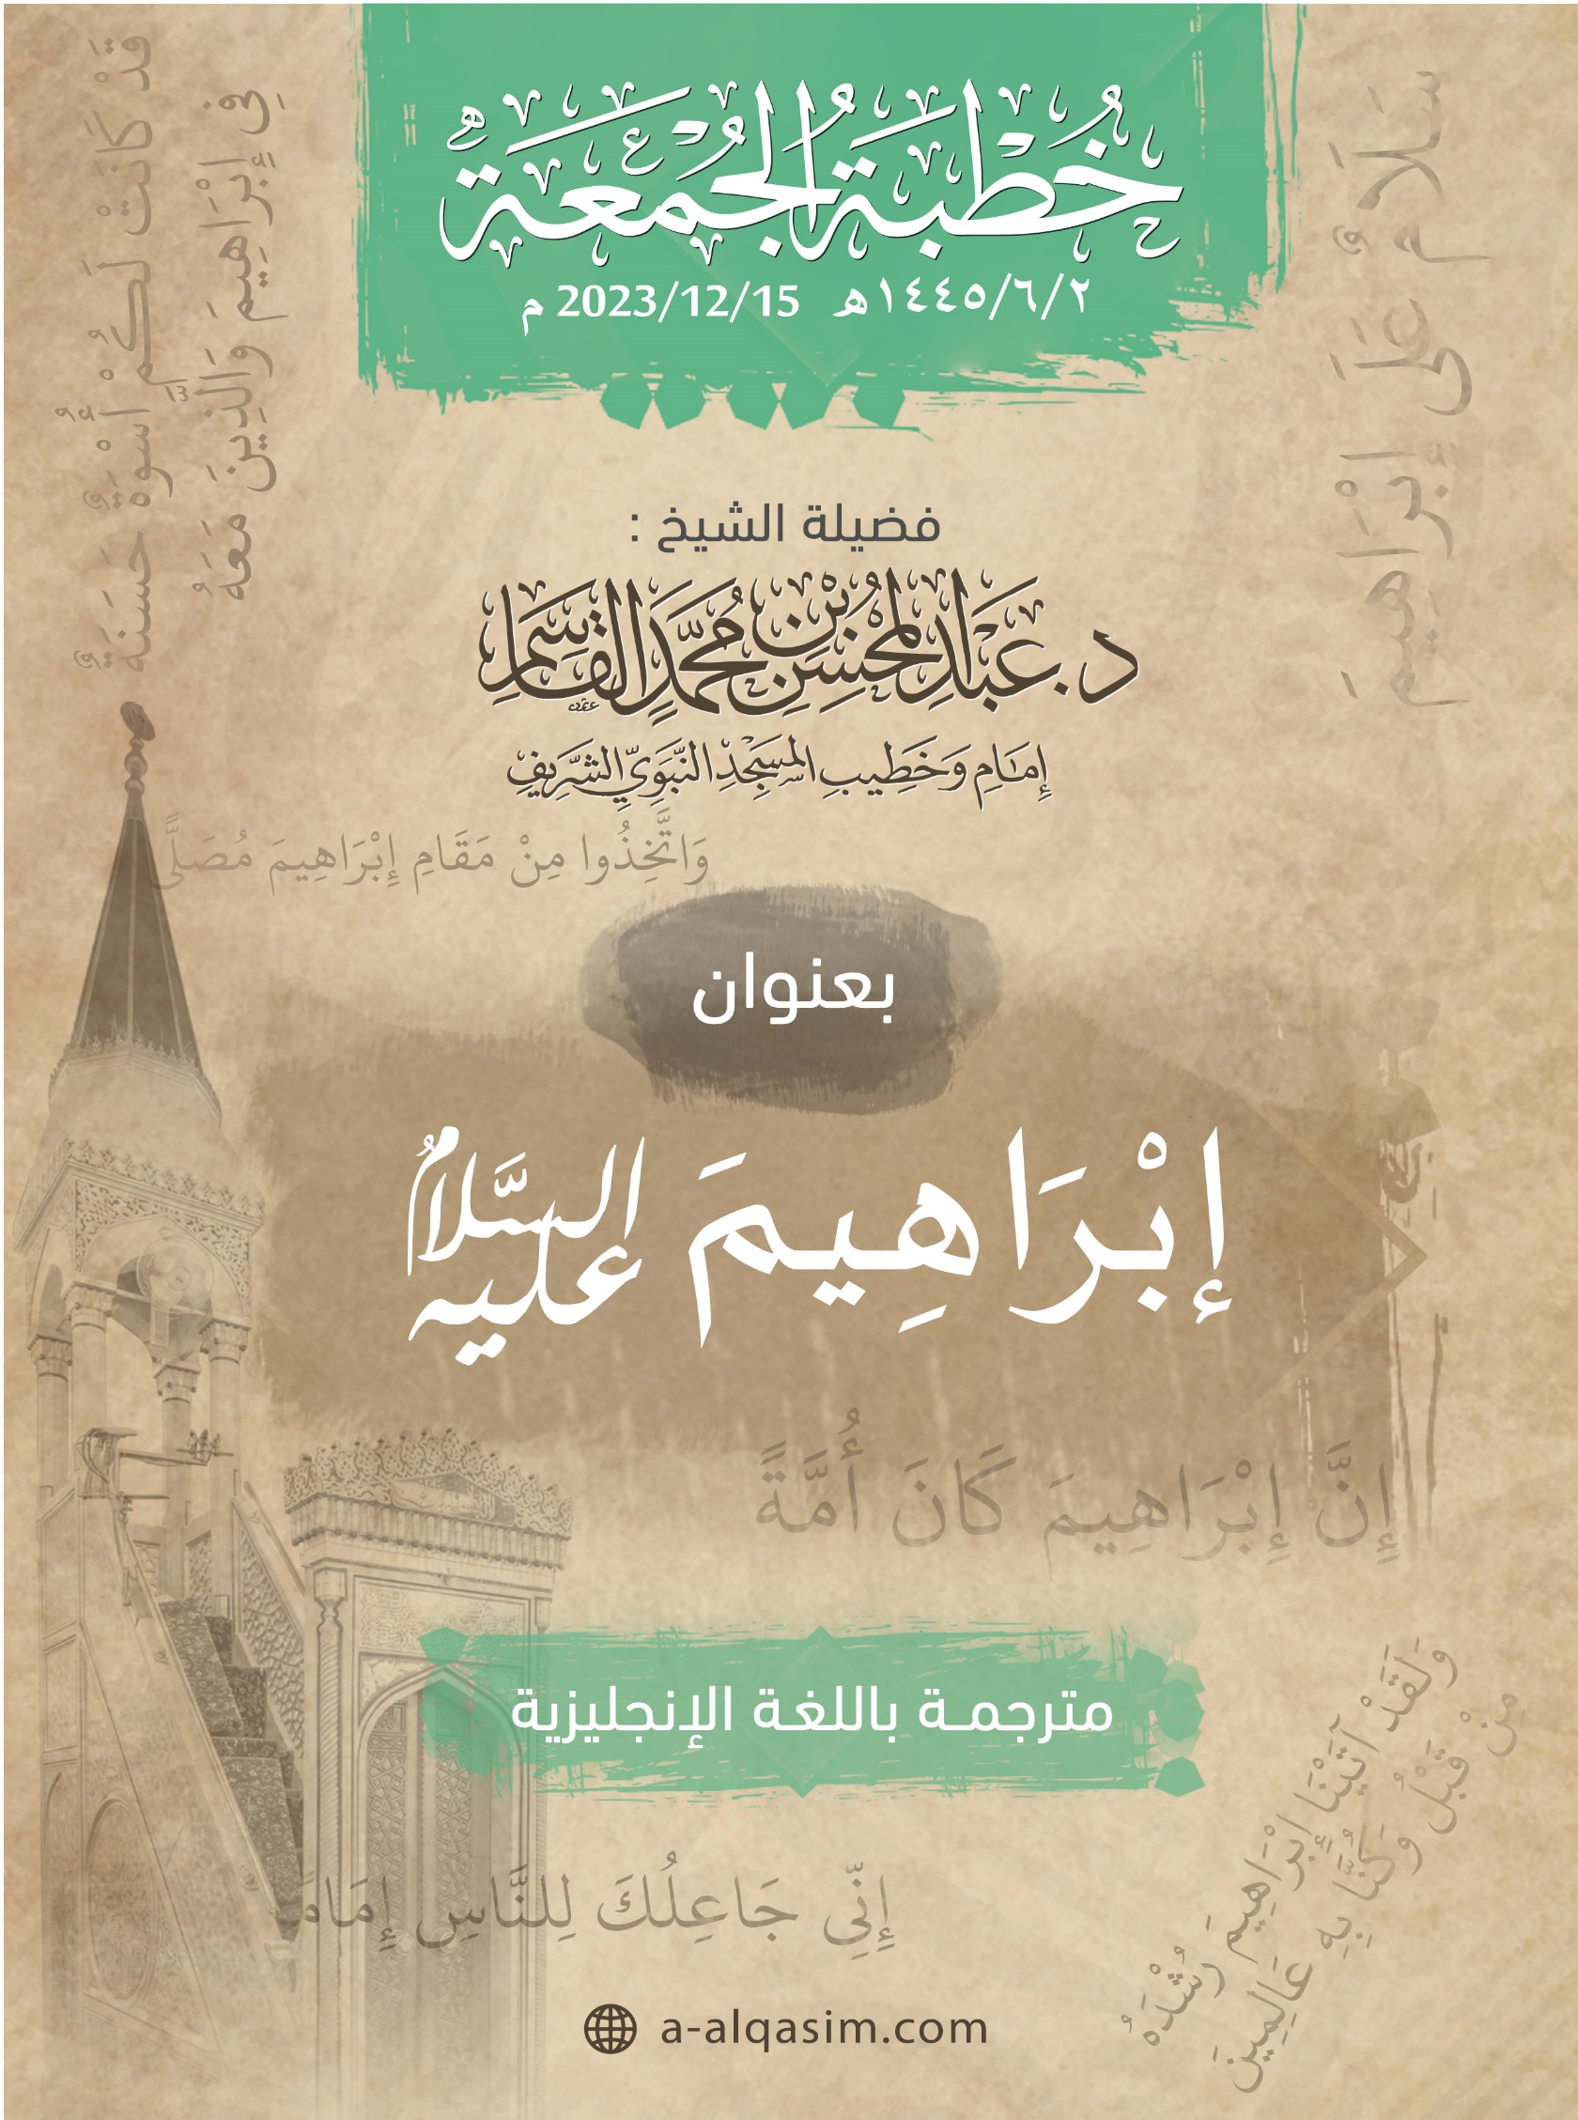

⁽⁾ This khutbah was delivered in Al-Masjid An-Nabawi on Friday the 2nd of Jumada Al-Akhirah 1445 AH.
[] Translator's note: "Amma ba‘d" is a phrase used to separate between the introduction and the topic of the sermon. It can be translated as: "To proceed".
[] Translator's note: "Ayyuhal-Muslimun" is an address meaning: "O Muslims".
[] Translator's note: When coming at the end of a sermon, this phrase can be understood to mean: "To conclude".
[] Translator's note: This phrase means: "I seek refuge in Allah from the accursed Shaytan".

